RESUME
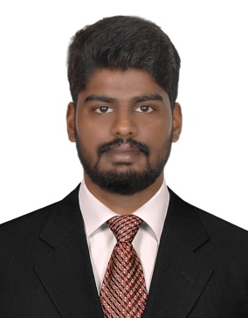

ADEL
Email: adel.388279@2freemail.com

Career Objective

Professional and dedicated Electrical Engineer seeking to take up a position in a result-oriented company that seeks an ambitious and career conscious person where acquired skills and education will be utilized towards the growth and advancement.
Academic Record
- Secondary Education
New Indian Model School, Abu Dhabi in 2012 with score 90%

- Higher Secondary Education (HSE)
New Indian Model School, Abu Dhabi in 2014 with score 85%

- Bachelor of Technology (B. Tech)Electrical & Electronics Engineering (2014-2018)
SCMS School of Engineering and Technology-affiliated to M.G University

Work Experience

Engineer Intern-Arabian Integrated Marine Services Establishment (6 months)
- Visiting the Site, Carried out inspection and module installation of Generator sets.
- Attending the Site for Panel inspection, configuration and installation
- Installation of motor and pumps with respect to the System.
- Verifying the default and assisting in Maintenance and Servicing of generator sets.

Internship Experience

Completed Plant Training in Install Tech (3 Months):
Successfully completed internship by attaining detailed knowledge about various panels, relays and their working and use in efficient working of households and factories.

Academic Projects & Achievements

- Main Project – Auto selection of power sources
Presented a project based on auto selection of sources by combining power from renewable sources and supplied electricity such that maximum efficiency with least cost is possible.

- Final year seminar– Optical switch based on fiber chip fiber opto mechanism
Proposed a system where optical switch with high extinction ratio is made possible using fiber chip fiber opto mechanism so that high switching properties is utilized in fiber optics

- Mini Project – Drone control using phones
Designed a project where a land or air drone can be controlled with phone with a given set of instruction

Software Skills

AUTOCAD MEP & ELECTRICAL

Completed training at TIMES TRAINING CENTERE, Abu Dhabi
AutoCAD certificate no: EM30361509674224331989

Windows XP‐MS word, MS Excel, MS Power point.
Excellent Working Knowledge with latest programs

MATLAB
Working Knowledge on analyzing data, developing algorithms, or
Creating models using MATLAB

Strengths

- Excellent Communication Skills
- Target driven, hardworking individual
- Ability to quickly identify and resolve problems
- Team Player

Language Skills

- English, Hindi, Malayalam, and Arabic (Intermediate)

Personal Details

Gender: Male
Nationality: Indian

