CURRICULUM VITAE
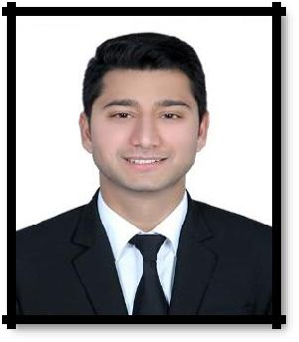

HARSH
Email: harsh.388281@2freemail.coom

OBJECTIVE

Seeking a position to utilize my skills and abilities which offers innovative growth while being resourceful, innovative and flexible. Ultimate objective is to enjoy my work and to it from core of my heart.

ACADEMIC AND PROFFESSIONAL QUALIFICATION

 | Examination |  |  |  | Board / University |  |  |  |  | Year of Passing |  |  |  | Grade
 | Aviation,Hospitality |  |  |  | Frankfinn Institute of Air |  |  |  |  | 2015 |  |  |  | Pass
 | and travel management |  |  |  | hostess training
 | Hospitality Diploma |  |  |  | Institute Of Commercial |  |  |  |  | 2015 |  |  |  | Pass
 | Level-5 certificate |  |  |  | Management, London, UK
 | Civil Engineering |  |  |  | PSTEB, Chandigarh |  |  |  |  | 2014 |  |  |  | A
 | Diploma
 | Senior Secondary |  |  |  | PSEB ,Mohali |  |  |  |  | 2011 |  |  |  | A
 | Higher Secondary |  |  |  | PSEB, Mohali |  |  |  |  | 2009 |  |  |  | A

Work Experience

UAE EXPERIENCE

- Working at Pre-Opening Emerald Palace Kempinski Palm Jumeirah as a Security Team Leader and CCTV Operator with Arkan management since May2018.

Responsibilities:-

- Handling Fire Alarm system (Site Monitor and Graphics)

- Handling CCTV system ( Endura WS5000 and Smart PSS)

- Handling Ving Card system

- Handling ANPR (Automatic Number Plate Reader) system

- Lost and Found system

PREVIOUS EXPERIENCE:-

- Worked at Indira Gandhi International Airport New Delhi as a Passenger Service Executive with Air France and KLM Royal Dutch Airline for more than One year through Celebi ground handling pvt. ltd. DELHI.

Responsibilities: -
- Check-in agent (Worked on Amadeus-Altea System)
- Documents Agent

- Boarding coordinator
- Meet and assistant

ATTRIBUTES :-

Hardwork, Positive Attitude, Believe in myself, Patience, Intellectual Person Determine.

Personal Profile

Gender | : | Male
Nationality | : | Indian
Height/Weight | : | 179 cm/ 73kg
LANGUAGE KNOWN

 | SPEAK | WRITE | READ
ENGLISH | √ | √ | √
HINDI | √ | √ | √
PUNJABI | √ | √ | √

