sarun

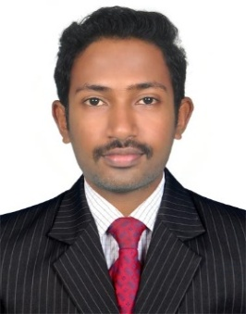

Email: sarun.388307@2freemail.com

Seeking a position in
FINANCE & ACCOUNTS/AUDIT

Career Objective

Seeking a position as Accountant where I can utilize my knowledge and experience in a reputed organization. Keep growing as accountant in the field of accounting transactions, bank reconciliation, bills payable and bills receivables etc. by developing my current skills, knowledge and experiences.

Work Experience And Articleship

- 2017 January-November, working experience with CA.Guruvayurappan V N, Chartered Accountant, Thrissur, Kerala.
- 2017 December-2018 November working experience with M/S Suresh Nair & Associates, Chartered Accountants, Thrissur, Kerala.

Job Responsibilities include

- Dealing bank accounts.
- Managing the overall functioning of business, interaction with clients, monitoring accounts and finance department.
- Have experience of maintaining book of Accounts.
- Experience in reconciling Bank Accounts, TDS etc.
- Experience of managing cash.
- Preparing and E-Filing of Income Tax, Service Tax and TDS Returns.
- Experience of preparation of budgets and reports.
- Have experience in Internal Audit of NBFCs.
- Experience in being a part of Statutory Audit & Tax Audit teams.

Achievements & Certifications

- Participated in the “Orientation Course” organized by Board Of Studies of ICAI.
- Participated in the “National Conclave for CA Students” organized by Board Of Studies of ICAI.

Educational Qualifications

Course | School/college/  University | Year  of  passing | %
BCOM | ST.THOMAS COLLEGE, Thrissur, Kerala | 2016 | 75
12th | V.B.H.S.S.Thrissur | 2013 | 95
10th | ASSISI E.M.H.S Thalakkottukara | 2011 | 90

Software Proficiencies

- SAP FINANCE Power User Certification obtained via SAP Education’s Enable Now Power User Program.
- Information Technology Training Course Certificate obtained from ICAI.
- Good control over MS Word, Excel and Power Point
- Proficiency in using accounting software (Tally ERP 9).

Languages Known

English, Hindi, Tamil, Malayalam

Personal Profile

Gender : Male
Marital Status : Single

