CURRICULUMVITAE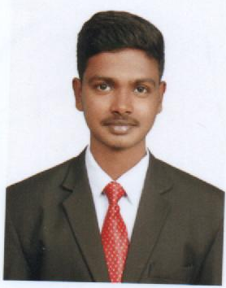

Gowtham
Email: gowtham.388318@2freemail.com

OBJECTIVE:
To work in an exciting and creative position where there is an opportunity to gain a wealth of knowledge, insight and experience to undertake challenging position by acquiring skills through continuous learning and determination.
EDUCATIONAL QUALIFICATION
COURSE | INSTITUTION | BOARD/  UNIVERSITY | YEAR OF  COMPLETION | AGGRE  GATE(%)
DHMCT & B.SC(HM) | Bharath institute of catering technology & hotel management | Department of technical education (DOTE) | JUN2015 to MAY2018 | 86%
HSC | Kalyanasundaram higher secondary school,Thanjavur | State board | JUN2014 to MAR2015 | 76%
SSLC | Kalyanasundaram higher secondary school,Thanjavur. | State board | JUN2012 to MAR2013 | 84%

SOFTWARE SKILLS:
- Ms office
- IDS software
- WINHMS software
- NUECIFERA software
AREA OF INTEREST:
- Finance department
- Front office department
WORK EXPERIENCE :
- Worked as a NIGHT AUDITOR in Lotus desaru beach resort and spa, MALAYSIA.
TRAINING EXPERIENCE:
- Trained as HOUSEKEEPER in Fortunepark galaxy ,vapi ,GUJARAT– Nov-21-2015 to Jan-10-2016(50 days)
- Trained as FRONT OFFICE ASSISTANT in Goldraysarovarportico,salem,TAMILNADU-June 2016 to July 2016(2 months)
- Trained as FRONT OFFICE ASSISTANT & F&B WAITERin Hotel Svatma,Thanjavur,TAMILNADU-Nov-30-2016 to March-30-2017 (4 months)
PART TIME WORK EXPERIENCE :
- Worked as a GUEST SERVICE AGENT in Hotel Raks, Thanjavur, TAMILNADU.
- Worked as a WAITER in Hotel Yahappa, Thanjavur, TAMILNADU.
PERSONAL DETAILS:
Nationality : Indian
Gender :Male
Marital status : Single
Languages known : Tamil,English
Hobbies : Drawing,reading books, playing games
Strength : HardWorking,punctuality,fast writing

