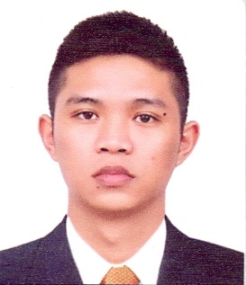
RAPHAEL
Email: Raphael.388323@2freemail.com

WORKING EXPERIENCE
Peninsula Electric Cooperative, Inc
Balanga City, Bataan, Philippines
Electric Utility Substation Site Engineer
June 2017 – May 2018
Maintaining the 10MVA Substation and providing field assistance for the Substation foreman and technicians, by responding to trouble reports ofHV and LV lines, Transformers and Service. Giving proper assistance and supervision for installation of service meters and service transformers. Assistance in 13.2kv and 220v cable laying of OH Service Drops and laterals, terminations, metering, insulation replacements, customer service and pole erections.
EDUCATIONAL ATTAINMENT
Bachelor of Science in Electrical Engineering
Bataan Peninsula State University
Balanga, Bataan 2112 Philippines
Attained June 2017
MOFA Attested Document
PERSONAL INFORMATION
CIVIL STATUS Single
NATIONALITY Filipino
LANGUAGES SPOKEN Filipino & English

Registered Electrical Engineer of the Philippines
September 2018Board Examination Passer
Board of Electrical Engineers, Professional Regulation Commission
License No. 70078

Regular Member of Institute of Integrated Electrical Engineers
IIEE Bataan Chapter, Central Luzon Region
Membership No. 84193
KNOWLEDGE AND SKILLS
Electrical
- Motor Control Basic Knowledge
- Knowledge in Electrical Engineering Theories
- Scheduling of Loads
- Distribution Box installation for single and three phase
- Installation of lights, switches and control panel
- Knowledge in generation, transmission and distribution systems
- Knowledge in electrical system design and electrical code
- Knowledge in transformers, motors and generators
- IEEE Device knowledge
- Transformer Connections and Sizing
- Cable sizing
Computer
- Microsoft Office Word and Excel
- Microsoft Office PowerPoint
- Microsoft Outlook

