PERSONALINFORMATION
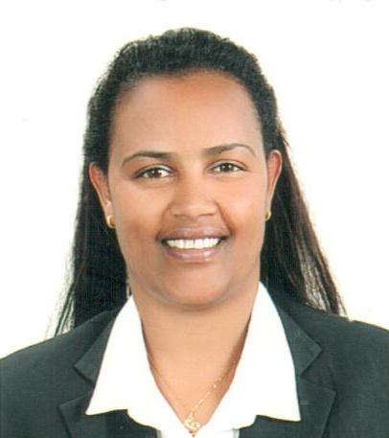

Name: Hana
Email: hana.388324@2freemail.com

Nationality: Ethiopia
Marital Status Married

OBJECTIVE

I possess the ability to work efficiently under pressure and can handle stress well. I am a smart worker and a quick learner. The vast expanse of Management and its profound application in serving mankind has always excited me. I enjoy looking for new challenges and working on them. I work effectively as a team and my passion for winning and self-confidence has always made me a high achiever. All of these make me a highly motivated individual that will be an asset to the organization I work in.
ACADEMIC QUALIFICATIONS
PERIOD | INSTITUTION | QUALIFICATION
2012-2012 | Zabeel international institute (Dubai) | Airline Management
2004-2004 | Delta computer institute( Ethiopia) | Computer Programs
2000-2003 | St. MaryCollege( Ethiopia) | Marketing management Diploma

WORK EXPERIENCE

Jumeirah Group (Wild Wadi)
Position: Security Team leader (Dubai-UAE) 2014 – present
- Ensure continual “on the job training” and coaching is carried out with all Assistant Team Leaders and Security Officers assigned to their team to maintain competence, correct errors and enhance performance of individuals and the team.
- Monitors correct completion of Security documentation and supervise key controls system.
- Supervises Security processes to ensure adherence to Jumeirah Policies & Procedures Completes Investigation Reports of Incidents, as and when applicable.
- Communicate new or amended procedures to relevant departments/ colleagues in a timely manner, ensuring they have been understood.
- Monitor the control department forms and records according to the Jumeirah standards for Document Control.
- Prepares daily incident reports, requisitions and other inter office memos as required, And not only these
Jumeirah Group (Wild Wadi)
Position: CCTV Operator (Dubai-UAE) 2010-2014
- Maintain the security and safety of Jumeirah property, colleagues and guests
- Carry out Foot and Vehicle Patrols, Access Control, Control of Keys, Emergency Respond and Notification, Public Relations
- Escalate all concerns in relation to Fire, Life & Safety issues to the Team Leader
- Monitor C.C.T.V. system, fire alarm panel, emergency telephone, elevator control monitor, and emergency lighting control monitor
- Safe custody of the lost and found items
- Monitoring VIP movements
- Maintaining files and cleanliness of the Security Control Room
- Performs all other related duties as directed by Management as appropriate

Jumeirah Group( Wild Wadi)
Position: Guest Service (Dubai-UAE) 2008-2010
- Handling Front Line operations from the point of arrival of the guest.
- Ensure that the service is provided with the right speed with a guest satisfaction.
- Ensure all Company Standards are met and cleaning work is carried out
- Assisting VIP Arrival

ADNH Amigo Supermarket
Position: Cashier (Dubai-UAE) 2006-2008

- Listening to customer requirements and presenting appropriately to make a sale.
- Gathering market and customer information.
- Negotiating on price, costs, delivery and specifications with buyers and managers.
- Challenging any objections with a view to getting the customer to buy.
- Advising on forthcoming product developments and discussing special promotions.
- Liaising with suppliers to check the progress of existing orders.
- Checking the quantities of goods on display and in stock.

Ras Hotel ( Ethiopia)
Position: Guest Service 2005-2006

- Deal directly with customers either by telephone, electronically or face to face
- Respond promptly to customer inquiries
- Handle and resolve customer complaints
- Obtain and evaluate all relevant information to handle product and service inquiries
- Provide pricing and delivery information
- Perform customer verifications
- Set up new customer accounts
- Process orders, forms, applications and requests
- Organize workflow to meet customer timeframes
- Direct requests and unresolved issues to the designated resource
SKILLS:
- Driving License ( Belhasa driving institute)
- Security Supervisor & CCTV Training. (Dubai Police)
- ProfessionalAdvance English Language Training. (Jumeirah Group)
- On Job & Team Trainer Training. (Jumeirah Group)
- CPR & First Aid Training (American heart Association)
- Food hygienic Training ( ADNH)
- Swimming license Training from (Wild Wadi Water Park)
- Idea & Voice

ACHIVEMENT
- Certified training from Jumeirah for Opera (PMS)
- Certified training in Luxury Butler Service from Jumeirah Madinat
- Certified training in Customer service executive from Jumeirah group
- Certified training how to use fire extinguisher from Civil defence
- Certified training Advance excel from Jumeirah Group
- Certified training Basic service skills workshop from Madinat Jumeirah
- Nominated as a colleague of the month &Team Leader of the month from 2008 up to
now.
- Certified implemented Idea &Voices for Great Innovation from Jumeirah group

COMPTANCY

- Excellent leading skills
- Exceptional communication and interpersonal skills
- Admirable skills on computers and numeracy
- Effective influencing and negotiation skills
- Strong communication skills
- Identity and solve customer needs
- Flexibility and availability
LANGUAGES

English-Speaking Listening &writing

Arabic Speaking Listening& Writing

