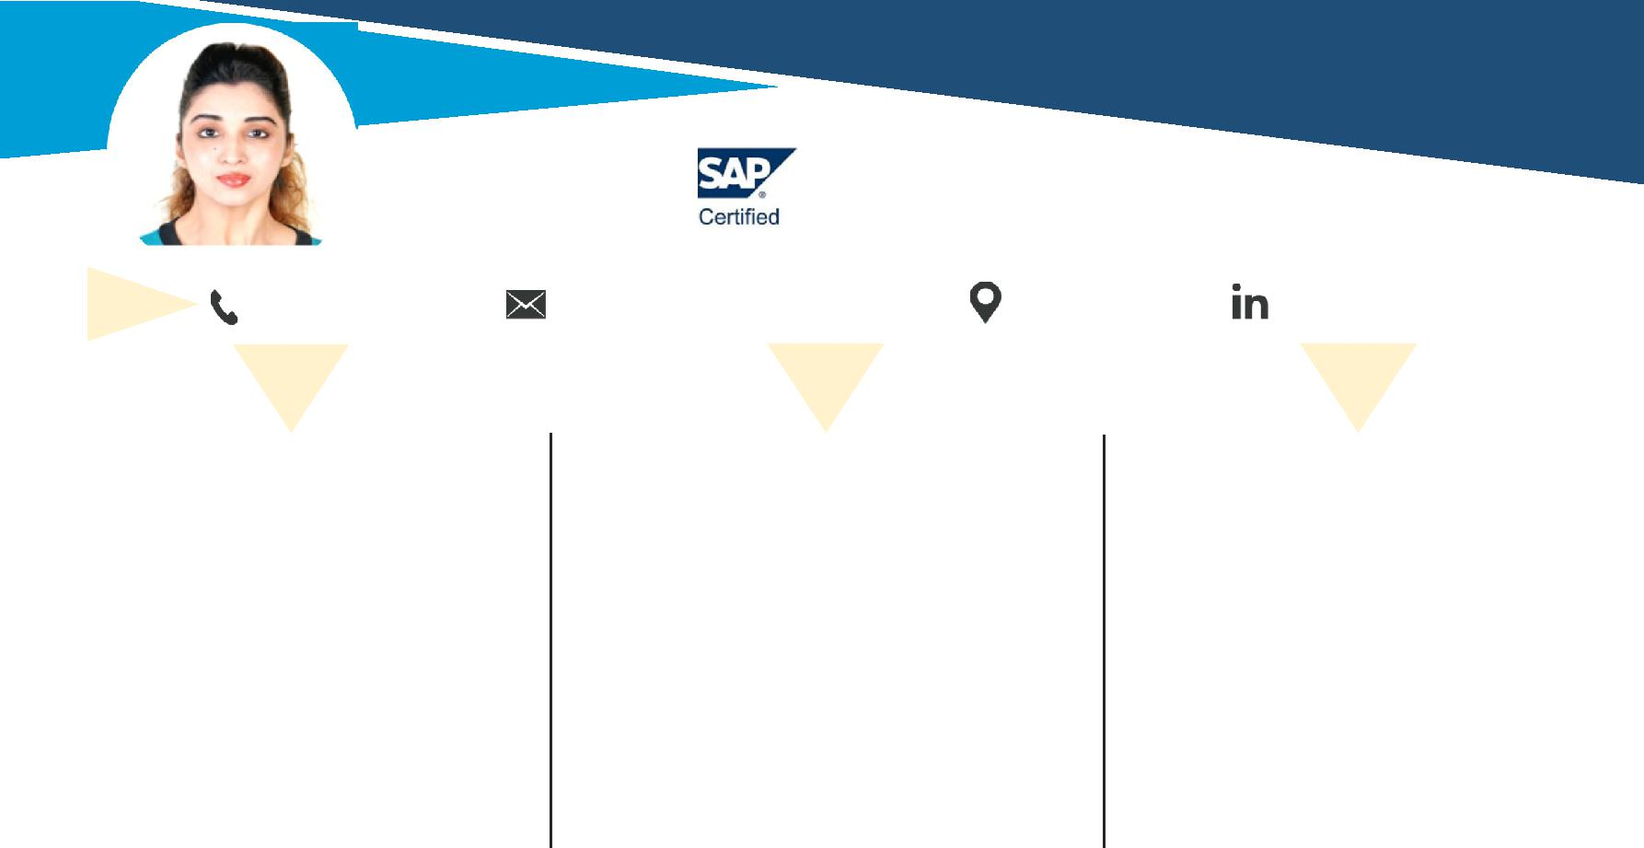

Vrushali |  | Vrushali-388367@2freemail.com | .
 | S T R E N G T H | P R O F I L E |  | E D U C A T I O N

- Conflict Management

- Leadership Quality

- Adaptability

- Interpersonal Communication

- Public Speaking

- Time Management

- Teamwork

- Office/ HR Manager with over 8+ years of experience assisting with and fulfilling organization staffing needs and requirements.

- SAP Certified with PG Diploma in Strategic Human Resources Management

- Aiming to use my dynamic communication and organization skills to achieve your HR initiatives.

- PG Diploma in Strategic Human Resources Management ‐ 2018
      - CIQ UK Westford University Sharjah, UAE

- SAP HCM Associate Certified with Distinction – 2014
      - Lithan Genovate , Mumbai, India.

  - B.Com ‐ 2009

    - Mumbai University, India.

S O F T W A R E S K I L L S P R O F E S S I O N A L

WPM: 90

MS Office 2016

SAP ‐ ERP 6.0

Tally 9.2. Version

IT Aakash Strategic ERP

Far Vision ERP SW

P E R S O N A L D E T A I L S

Date of Birth: 6th October 1987

Nationality : Indian

Driving license: UAE Valid till 2021

UAE Visa Status: Employment Visa

Marital Status: Unmarried

.

Hobbies: Gym Enthusiast, Driving,

Swimming & Traveling.

Languages: English, Hindi, Marathi,

Gujurati and Basic Arabic.

HR Admin Officer & Personal Assistant

Bin Al Mulla Constructions‐ Dubai (San Marco General Trading)

– Jan 2017 ‐ March 2019

End‐to‐End Recruitment Joining Formalities & Induction Accounts Attendance

Grievance Employee Relationship Performance Appraisal Exit Formalities

Job Evolution Compensation Employee Welfare Business Development

Accomplishments:

- Initiated revision of outdated employee handbook, HR policies and procedures.

- Created a company culture initiative, social events, employee satisfaction surveys which raised employee satisfaction rates by 25%

- Merged existing benefit plans into one corporate flexible benefit plan with annual savings while enhancing benefits to all employees & employer.

- Implement a Computerized & Hard copy filing system for human resources, organizing more than 300 past and current employee documents & Safe Keeping.

- Implemented a bi‐monthly meeting with all store heads to discuss goals, updates, and challenges, increasing productivity across all shops by 20%

- Reimagined business development strategy to include a 20% increase in sales force, resulting in increased profits.

Sr. Hr Administrative & Business Developer

Precision Global Services‐ India ‐ Nov. 2009 – Aug 2016

Recruitment Staff Induction MIS Report Attendance Employee Relationship

Payroll Benefits Petty Cash Admin Assistance Housekeeping Supervision

Stationary Management Business Research and Analysis Client Satisfaction & Engagement

Accomplishments:

- Increased productivity by 60% by implementing computerized inventory systems.
- Maintained 86% satisfaction rating as a customer care representative.

- Exceeded retail sales goals by an average of 17% every quarter in 2017.

