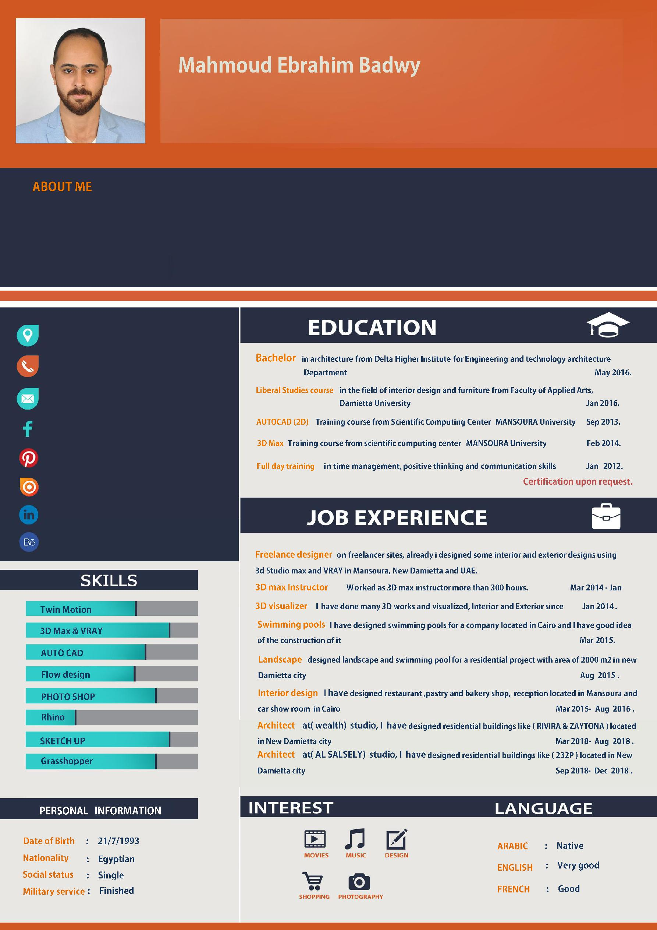
Architect
Interior designer & 3d visualizer
Mahmoud_388527@2freemail.com

Iam Mahmoud, a dreamer , perfectionist and i use to doubt about what Iam doing to reach every time a result which can make me happy .I believe in hard work but not without hard fun . Architecture is about ideas and drawings, about resolving problems and creating solutions .I think that ideas are one of the most powerful viruses for people. Once you know about something or see something you will have this idea in your mind forever. I like to have my personal shape of mind but i know that we are always learning something new every day.

