2017-03 -

2018-04

2016-02 -

2017-03

2014-08 -

2015-10
Anokhitha

Email: anokhitha.388639@2freemail.com

Advanced Tax Analyst

Summary

Advanced Tax Analyst with MBA (Finance) and 3+ years of experience. Seeking to leverage my technical and professional expertise to learn and grow in the new role at your company.

Experience

Advanced Tax Analyst

Ernst &Young, Bengaluru, India

-Trained New Joiners on the process and signed off on their work - Conduct group classes on the process to juniors in team.

-Team Coordination and conduct Team presentations during meetings.

-Review and sign off on the Quarterly reviews on the payroll sheet of assignee's.

- Global compensation and payroll data collection for multiple clients and reconciling it.

-Sign off on the W2 Forms filled by the team and sends it to On shore Teams in USA during year ends.

- Payroll Reporting and preparation of Balance sheet.

- Coordination with the assignee's.

- Preparation of Payroll instructions and tracking.

- Preparation of Tax Payments and processing.

- Following up with the different sources to gather compensation data on regular bases.

- Respond to tax teams requests and queries.

- Reporting compensation data in the year end to the Tax teams for filing tax returns.

Achievements:-

-Won Extra Miller Award for Quality of work Q4

Transaction Processing Associate

Accenture India (AB Inbev-Captive Unit), Bengaluru, India

- Job Transition done for the whole process from Belgium for 3 weeks.

- Tax Manual Payment processing for all the assignees travelling in Europe.

- Tracking the Tax Reimbursements from the Tax Authority and Assignees.

- Creating Purchase Requisition and Purchase Orders for the assignees travelling within Europe and USA for the Mobility Process.

- Preparing the International Mobility Tracker for maintaining all the assignee data travelling within Europe and Frequent Traveler and preparing deck monthly.

- Preparing Legal Compliance Report monthly.

Achievements:-

-Won award for Excellence in work for Q1,Q2,Q3

Advanced Tax Analyst

Ernst &Young, Bengaluru, India

- Analyzing compensation data of US touching and Third country national assignee's.

- Global compensation and payroll data collection for multiple clients and
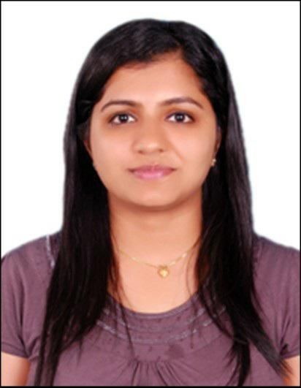

Personal Info

Date of birth

1991-02-04

Marital status

Single

Citizenship

Indian

Core competencies

Project Management

Problem Solving

Team Management

Report and Documentation

Training and Development

Languages

English

Hindi

2012-05 -

2014-07

2009-06 -

2012-06

2019-02

2019-02

2012-04
reconciling it.

- Preparing Shadow payroll reports, Year to date reports & providing it to country specific tax teams on monthly bases.

- Respond to tax teams requests and queries on Tax Reports

- Matching Year to date compensation data collected with W2 Box-1.

- Performing independent research on compensation reports quarterly and communicating findings to seniors.

Achievements:-

-Won Spot Award for Q1 2014

Education

CMR Institute of Technology (CMRIT), Bengaluru

- Master of Business Administration (Finance)

- First Class 63.15% with no history of back logs

- Prepared a project on : A study on Capital Structure of Overhaul Division (Hindustan Aeronautics Limited, Bengaluru)

- Coordinated and conducted Inter College Business Fests in campus.

St. Aloysius College, Mangalore

- Bachelors in Business Management (Finance)

- First Class 69.58% with no history of back logs.

- Took part in and won numerous prizes in various cultural programs and literary competitions.

Certificates

Tally ERP 9

Diploma in SAP FICO

Diploma in Business Computing

