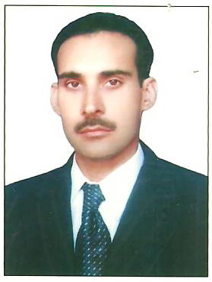
CURRICULUM VITAE

DIN
Email: din.388755@2freemail.com

Post Applied for: Driver,Salesman,Storekeeper,PRO
________________________________________________
Objective:
To demonstrate well developed planning, analytical and communication skills in a consistently high level of performance in a variety of progressively responsible and challenging assignments.

Qualification:
High Secondary Certificate

D.Com passed from government board of education, Peshawar Pakistan

Employment Details:

- 15 years' experience as driver with national taxi.
- 2 years experience as a supervisor/storekeeper with KNITTING COMPANY in Karachi Pakistan
- 2 years experience as a salesman with Abdullah Saeed Ibrahim Trading co Toyota spare parts shop Dubai UAE

Personal Details:
- Nationality Pakistan
- Religion Islam
- Marital Status Married
- Date of Birth 08 Feb, 1969
- Driving License Light Motor Vehicle

Core Competencies:
- Excellent written and verbal communication skills
- Decision-making
- Problem analysis and problem-solving
- Team-leadership
- Formal presentation skills
- Persuasiveness
- Adaptability
- Innovate

Language:

- Professional in oral as well as written English, Arabic,Hindi, Urdu, Pashto Communication.

Extra Curricular Activities and Interests:

- Playing Cricket.
- Traveling
- Reading books

