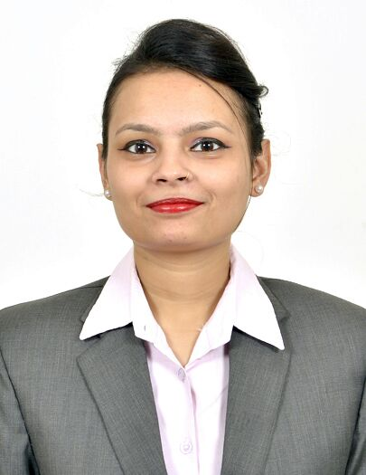
Curriculum Vitae
KHUSHBOO
Email: khushboo-389043@2freemail.com

CAREER OBJECTIVE
To work in challenging environment and give my best to the job assigned for the development of the organization and self in pursuit of excellence.
PERSONAL STRENGTH

- Excellent communication skills
- Sincere , Hard working , confidence
- Love to meet and interact with people respect human values.
- Identifying and solving problems
- Ability to work under pressure
- Ability to learn new task quickly

AREA OF INTEREST
- Front Office

EDUCATIONAL QUALIFICATION
- Secondary from CBSE in 2010 with 56%
- Sr. Secondary from CBSE in 2012 with 75%
- B.Com. from University of Rajasthan in 2015 with 61%
- Diploma in Catering Science and Hotel Management.
PROFFESSIONAL QUALIFICATION
22 weeks industrial training in all four departments from Hyatt hotel, Ahmedabad, India

Job Responsibilities

- Handling guest complaints and concerns in an efficient and timely manner
- Overseeing VIP guests, arrivals and departures
- Providing information regarding the hotel, town attractions, activities etc.
- Maintain all guest folios in the manner instructed and type out necessary guest likes and dislikes to the appropriate fields on the profile.
- Collect guest feedback during guest departure along with his likes and dislikes.
- Perform cashier activities.
- Allocate rooms to all arriving guests.
- Maintain guest lockers for safe custody.

Professional Experience
- 1 year experience as a Guest relationship Executive with lords hotel Jaipur
- 1 year experience as a receptionist in royal orchid hotel jaipur
- 7 months experience as a guest relationship executive in fortune royal hotel fujairah, UAE

ACHIEVEMENTS
- Rewarded for Dance Competition at School Level.
- Rewarded for Miss Fresher in College.
- Certificate for painting competition at School.
- Certificate for National Science Olympiad

HOBBIES AND INTEREST
- Dancing
- Listening Music
- Singing
- Watching TV

KEY SKILLS AND ATTRIBUTES
- Good knowledge of IDS, WINHMS and OPERA
- Basic Knowledge of Computer
- Sound Knowledge of Internet
PERSONAL INFORMATION
Date of Birth : 13/08/1993
Nationality : Indian
Marital Status : Single
Language Known : English, Hindi & Bengali

