Dimple

Email: dimple.389431@2freemail.com

SUMMERY
A year of professional experience in staffing and recruitments. Good experience in handling Full Life Cycle Recruitment, Well Experienced in utilization of Internet Technology in Recruiting Technical Talent Extremely organized and capable of independently handling all aspects of Hiring & Placements.
Schedule and coordinate interviews with Managers and candidates, maintaining relations with other agencies and consulting companies.
A quick learner with exceptional organizational, interpersonal, communication, negotiation and account management skills. Possess excellent knowledge of recruiting and hiring processes including sourcing, interviewing, reference checking, tracking, salary negotiations, and closing.

EXPERIENCE

HR Recruitment
Allegis Group
June 2018-Febraury 2019. India

Sourcing - Search and identify the suitable profiles from internal database (RWS) & registered job portals like CareerBuilder, indeed and LinkedIn etc.
Screening - Perform initial screening by telephonic/personal interviews for shortlisting the right candidates.
Selection - Schedule interviews of shortlisted candidates, scheduling interviews with hiring manager, follow up on the interview feedback and candidate selection.
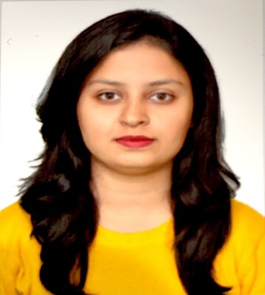

Zzzz EDUCATION
Bachelors in Business Management:
Dayananda Sagar Business Academy
(2013-2017)
Bengaluru, India

KEY SKILLS
*Recruitment and selection
*Onboard and induction
*Learning and development

PERSONAL DETAILS
Date of birth: 14th May 1995
Nationality: Indian
Language: English Hindi Kannada and Marathi

INTERNSHIP EXPERIENCE
*Bosch PVT LTD
HR auditing
Bengaluru India
of doc *Jagdale group of industries PVT LTD.
Bengaluru, India
Topic: To understand the customer perception over the company products (Bejois Juice).

Documentation - Working on Taleo. Modification of Job description, publishing vacancy, verifying candidate’s profile, Offer preparation, verification of documents for visa application and initiating visa application process.
MIS - Update & share the weekly recruitment tracker with the business e.g. hiring status, joining dates etc.

ADDITIONAL QUALIFICATION
- Event Manager
- Participated in the workshop training on Public Speaking, Interpersonal skills and working in teams.
ACHIVEMENTS
- Received certificate as “Master of Ceremony For All The Events”
- Received 1st prize in “Budget 2014” Presentation
- Received 1st prize in HR – ROLE PLAY in 5th Semester
- Certified classical dancer
PERSONAL INTEREST
Dancing, hosting, organizing events, badminton, reading books, photography and swimming.

