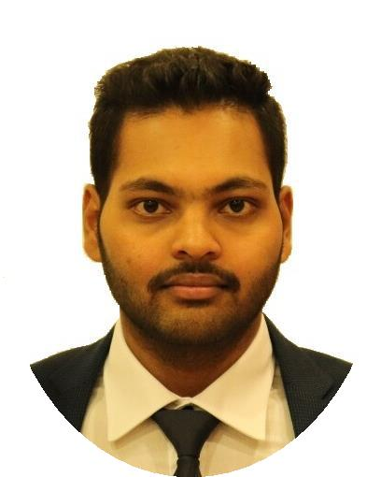

PROFILE

Recently completed Master’s in Building and Architectural Engineering from Politechnico Di Milano University, in Italy,

interested in expanding professional experience relating to my career, whether in interior and exterior Architecture. I am an excellent team worker and can take instructions from all levels and build up good working relationships with all colleagues. I am creative and logic. Outgoing and responsible and I like an international work environment. Since I am willing to learn and get more experience from the best, I am very interested to work in your company.

ARUN KUMAR A

Architect & Civil Engineer

Arunkumar-389875@2freemail.com

EDUCATION

 | JNTUA UNIVERSITY |  | Bachelor’s in civil engineering
2011-2015
 | POLITECNICO DI MILANO |  | Master’s in Architectural engineering
2016-2018
 | UNIVERSITY OF SAINT |  | For a semester as Exchange Student
 | JOSEPH
2018-2018
 | EXPERIENCE
SOUTH WESTERN RAILWAY |  |  | Bridge Engineer
2015-2016 |  |  | It is one of the largest Railway projects of
 |  |  | Govt of India. They are building railway
 |  |  | lines with bridges. I am a part Planning, co-
 |  |  | ordination and supervision of technical
 |  |  | aspects of major bridges.

CONTACT

HOBBIES

Visit Civil Summits

KUTEER INTERIOR
2012-2015

Master’s Thesis
2018-2018

SKILLS

Interior Decorator

Meet with the client to determine style, budget and needs then plans the space, using a CAD program, furniture options and interior layout.

Hybrid High Rise Twin Tower

On the request of Govt of Macau, as a city is very dense, proposed a Hybrid High Rise twin tower of 30 floors each with multiple functions at different levels of the building.

Attending work shops

Travel Cooking

Music Sports

Design |  | Imaginative

Creative Communication

Logic |  | Drawing

