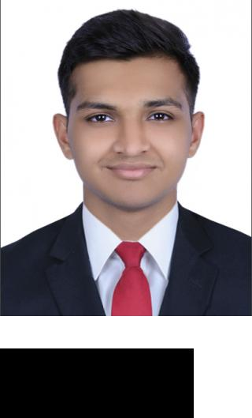

PERSONAL INFORMATION

OBJECTIVE

EDUCATION

WORK

EXPERIENCE

SKILLS

Urvash Sanjay Thanki
Urvash-389881@2freemail.com

Date Of Birth | - | 28 April 1998
Nationality | - | Indian
Religion | - | Hindu
Visa Status | - | Visit Visa

I am looking for an opportunity in a reputed organization which will help me deliver my best and upgrade my skills and meet the demands of the organization.

 | Higher Secondary Education |  | June 2015 — Feb 2016
 | (Maharashtra Board).
 | Seth Hirachand Mutha College
 | Main Course - Commerce
 | Marks | - 53 Percent
 | Bsc in International Business & |  | Sept 2018 — Present
 | Economics
 | Madonna University, Dubai
 | Data Entry Analyst |  | August 2017 — March 2018
 | Data Entry Analyst

Responsibilities:

Interpreting data, analyzing results using statistical techniques.
Developing and implementing data analyses, data collection systems and other strategies that optimize statistical efficiency and quality.
Acquiring data from primary or secondary data sources and maintaining databases.

Photoshop

Accounting

MySQL

Microsoft Excel

Communication

Time Management

Self - motivation

Leadership

Urvash Sanjay Thanki 1

MS Word

Power Point

Urvash Sanjay Thanki 2

