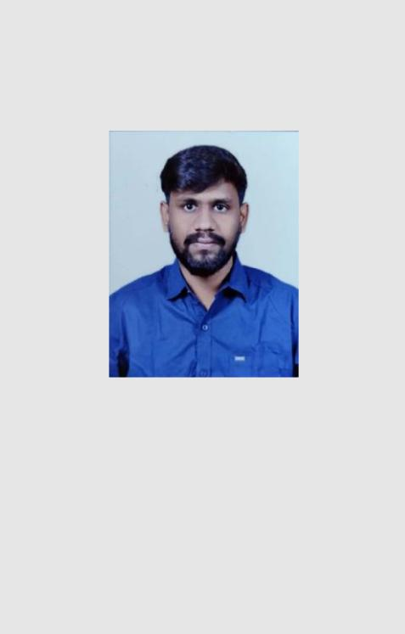

SETHUPATHI

27 January 1995

ABOUT ME

A Diligent and enthusiastic client service specialist with two years of experience in customer facing & support roles My passion for technology is contagious has to share the benefits of innovative products with customers and instruct them on usage sale is almost inevitable.

SKILLS

WORK

- Teamwork

- Ability to work under pressure

- Microsoft applications
- Problem solving
- Documentation

- Time management
- Customer handling

PERSONAL

COMMUNICATION

ORGANIZATION

TEAM PLAYER

CREATIVITY

SOCIAL

INTEREST

- SPORTS
- SWIMMING

- TRAVELING

SETHUPATHI
CUSTOMER SERVICE EXECUTIVE

Email: sethupathi.389932@2freemail.com
EXPERIENCE

(05/2018 – present)

CUSTOMER SERVICE EXECUTIVE
MINICABS AIRPORT TRANSFERS

International voice UK-based company to provide cab service through calling at London airports for customers

Answer incoming phone calls, schedule taxi cab trips in London airports by allocating the drivers and enter trip orders into the dispatch computer.

My main role is to book the cab for the customers and allocate the drivers in London airports by maintaining good customer relationship.

(12/2016 –04/2018)

ADMIN ASSISTANT CUM CUSTOMER SERVICE
MADRAS NDT TECHNOLOGIES

NDT company is one of the leading in Non- destructive testing (NDT) training & services for Quality and Inspection – Manufacturing

Providing general administrative and customer support including mailing, scanning, faxing and copying to management.

Installing, configuring, and updating hardware and software, as well as fixing any issue related to the equipment that may come up on a daily basis over the phone.

EDUCATION

(2013 – 2017)

BACHELOR OF ENGINEERING
NEHRU INSTITUTE OF ENGINEERING & TECHNOLOGY

AWARDS

ROBOTRYST 2015

AEROWINGS 2016

INNOVATIVE DESIGN QUADCOPTER – MINI PROJECT 2016 REDUCTION OF INDUCED DRAG – MAIN PROJECT 2017 DISTRICT PLAYER IN CRICKET AT ZONAL LEVEL 2014

