3/30/2019
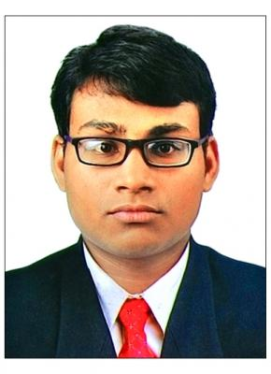

Ashik

ACCOUNTANT

A seasoned professional seeking a career in an organization that provide challenging environment to utilize my expertise and ensures a continuous learning process and provide exposure to new ideas that stimulate personal and professional growth.

Email ID:

Ashik-389940@2freemail.com

Skills

Integrity

Timeline

Assets

Quick Learner

Analytical Ability

Quick Calculator

Teamworking Ability

Languages

English

Hindi

Computer skills

MS EXCELL

QUICKBOOK

TALLY ERP 9

PEACHTREE/SAGE50

SAP MM, FICO, B1

Visual Basics

From Jun. 2007 to

Mar. 2008

From Jun. 2008 to

Mar. 2010

From May 2010

to May 2013

From May 2013

to May 2015

From Dec. 2013

to May 2016

From Jun. 2016 to

Apr. 2017

From Apr. 2017 to

May 2018

From May 2018

to Jan. 2019

SSLC

Mar Augustine High School

Angamaly

Higher Secondary

St. Joseph H.S.S Angamaly

B.Com(Computer Application)

Nirmala Collage/ MG

University Trissur, India

M.Com(Finance)

St. Mary's Collage, MG University Perumbavoor, India

Assistant Accountant

Indus Valley Fertilizers Private Limited Ernākulam, India
Stock, Godown

Management

Assist with all departments

Accountant

Devan Trade Links Ernākulam,

India

Godown Management,

Accounts Receivable and

Payable

Reconciliation

Accountant

GoodHew Ernākulam, India

General Accounting(include All accounting works) Payroll Management Handled HR Department

Accountant

Accounting Service Socity

Ernākulam, India

Project works

VAT and GST Filing

Devoted towards work

Software Knowledge

Interests

Finding shortcuts for calculation

Travelling

Music

Photography

Passport Details

P P Number | : N0691320
Date of Issue | : 07/07/2015
Date of Expiry | : 06/07/2025

Visa Details

Visit Visa / Convertible Visa Visa Expires on JUNE 2nd

1/1

