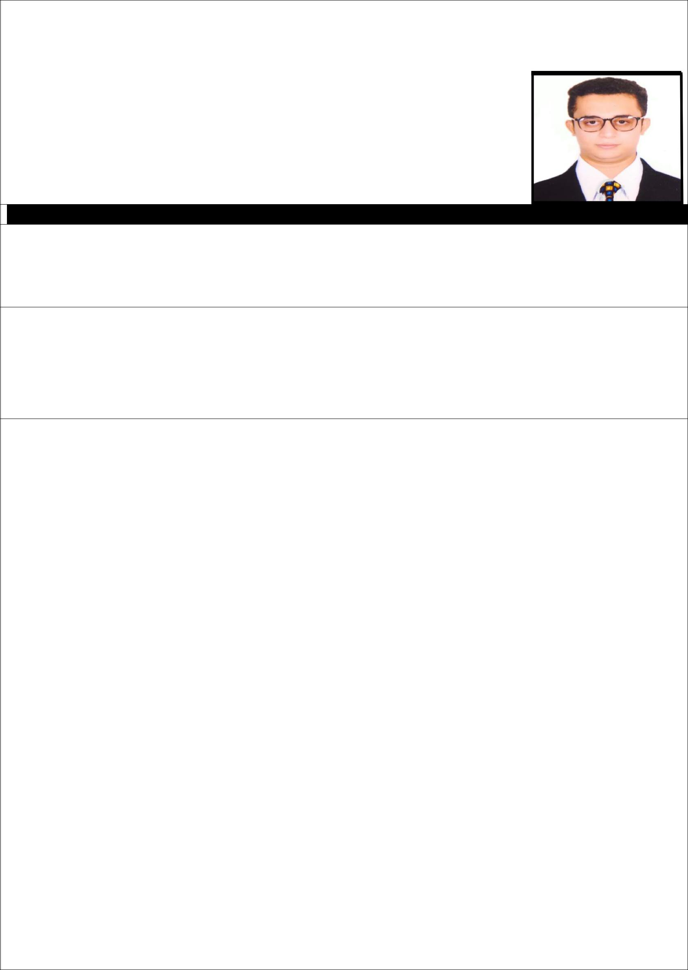
Curriculum Vitae

Objective:

To work as a key player in a creative and challenging environment using cutting edge technologies where I can constantly learn and improve my technical and analytical abilities and utilize my potential by successfully delivering solutions to serve in creating a better world.

Name : Arfat

Email : arfat.389989@2freemail.com

- Bachelor of Engineering (B.E) in Electronics & Telecomm in 2017 from Mumbai University.

- Diploma in Electronics & Telecomm in 2014 from Mumbai University.

- Industrial Automation in PLC (Allen Bradley , Siemens ( S7 300 ) , Modicon and GE Fanug , SCADA , HMI ( AB-Panel View ) , Drives , DCS and Instrumentation .

Skills:
- Programmable logic controller (PLC).

- Micrologix.

- Sequencial logical controller (SLC) 5/03.

- Ladder Programming.

- RS Logix 500 , RS Linx , Intouch , Momentrum ( Unity pro ), Versamax & 90/30, Logix , AC Drives ( Delta ).

- Hydraulics and Pneumatics.

- MS Office etc.

PROJECT:

TRAVOLUTION:-(Complete vehicle drive safety and security system)

This project is used to reduce the accidents due to drink and drive, high speed of vehicle also used to reduce the unwanted noise in prohibited areas and the system used in project provides security and missing vehicle location if vehicle is misplaced this all features are namely Alcohol detection, Thief detection, speed control, Horn control and Collision control.

LANGUAGE KNOWN: English, Hindi, Marathi, Urdu.

STRENGTH:-

- Confidence

- Punctual

- Positive Attitude (creative a positive work environment)

- Creativity

- Responsible

HOBBIES:- Playing Cricket, Travelling, Interacting with new People.

PERSONAL INFORMATION:

Date of birth Gender Marital status Nationality

27th Jul 1994.

Male

Single

Indian

