TAUFIQUE
Email: taufique.389991@2freemail.com

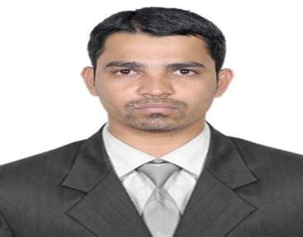

- Objective: I am looking forward for a challenging and rewarding career which is financially satisfying and career promising, that will not only permit to demonstrate my abilities more fully but also will enable me to expand my knowledge and experience.

- Work Experience:
- Worked for M.H.Baderpura & Co Mumbai India as a Accounts Assistant from Feb 2017 – Jan 2019.

- ROLES AND RESPONSIBILITIES:
- Dealing with day-to-day cash and petty cash transactions and keeping control over expenses.
- Maintenances of all books of accounts like Purchase Register, Sales Register, Petty Cash Book, Cash Book, Journal, Ledger, etc.
- Handling banking transactions and prepare bank reconciliation statement.
- Preparing Income Tax, Sales Tax & M-VAT Returns and G S T Returns.
- Follow-up for Payments from Clients.
- Meeting with Clients and Quick response to query of client.
- Worked for Hotel Mina International as a Accounts Executive from March 2015 – Jan 2017.

- ROLES AND RESPONSIBILITIES:
- Dealing with day-to-day cash and petty cash transactions and keeping control over expenses.
- Maintenances of all books of accounts like Purchase Register, Sales Register, Petty Cash Book, Cash Book, Journal, Ledger, etc.
- Handling banking transactions and prepare bank reconciliation statement.
- Quick response to query mails of client and Suppliers.
- Follow-up for Payments from Clients.
- Making Payment of Suppliers on time.

- Worked for M.H.Baderpura & Co Mumbai India as a Accounts Clerk from Feb 2013 – Feb 2015.
- ROLES AND RESPONSIBILITIES:
- Maintenances of all books of accounts like Purchase Register, Sales Register, Petty Cash Book, Cash Book, Journal, Ledger, etc.
- Handling banking transactions and prepare bank reconciliation statement.

- Educational Qualification:
- Graduated in Commerce from Mumbai University in Oct 2012 with major subject Financial Accounting and Management Accounting.

- Personality Details:
- Hardworking
- Honest
- Enthusiastic
- Professional.

- PC Skills:
- Tally ERP.
- MS Office.
- Internet & E-mail applications.

- Languages:
- English, Urdu, Hindi, Marathi.

- Extra-Curricular Activities:
- Actively Participated in Inter-College activities.
- Awards in Cricket.

- Personal Details:
Name : TAUFIQUE
Nationality : Indian
Date of Birth : 15 March 1991
Marital Status : Single

