Curriculum Vitae
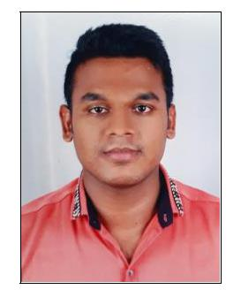

Husain
Email: Husain.390043@2freemail.com

Career Objective:

To make sincere and continuous efforts towards building a promising career and to take challenges in life so that I can contribute to the growth and success of organization while being innovative and flexible.

Experience:

- Gulf experience – 2 years

- Working as a WAITER in Three star hotel “Hotel Sea Sand” in Mumbai (India) from May 2015 to May 2017.

- Working as a WAITER in Four Star hotel “ Atlantic Hotel ” in Mumbai (India) from June 2013 to April 2015.

- Working as a WAITER in Four star hotel “Hotel Grace Residency” in Mumbai (India) from March 2011 to June 2013.

Duties:

- Assist with preparation of cooking menu items.
- Maintain kitchen equipment & observes all sanitation rules.
- Check all items to ensure adequacy and quality.
- Washing, cutting and preparing food before it is cooked.
- Making sure good nutritional standards are maintained when preparing meals.
- Follow the company rules & regulation.

Personnel Skill:

- Excellent customer service skills

- Able to work as part of a team.

- Relaxed personality with excellent communication skills

- Eager to learn new recipes and cooking techniques

Academic Qualification:

- S.S.L.C ( Secondary School Level Certificate )

Personnel Details:

Name
Language Known
D.O.B
Gender
Nationality
Religion

Marital Status

