OBJECTIVE:

To pursue a career in a profession organization this could guide and assist my caliber to meet my discipline, honesty, hardworking for achieving the target.

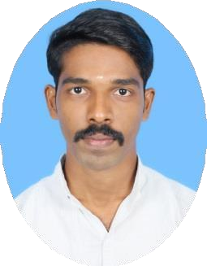

SUDEESH

EMAIL:
sudeesh-390083@2freemail.com

PERSONAL DATA
Date of Birth : 26-08-1994 Nationality : Indian Sex : Male
Religion : Hindu Marital Status: Single

LANGUAGES KNOWN
English, Tamil, and Malayalam
PROFESSIONAL EXPERIENCE:
Worked as a Production Engineer in Abner India Precision Tools, Coimbatore from January 2017 – December 2018
KEY DUTIES:

- Handling the man Power
- Allocation of job according the shipment date.
- Preparing the job card based on the process and Necessity.
- Maintains quality service by establishing and enforcing organization standards.
- Maintains work flow by monitoring steps of the process

PERSONAL SKILLS:

- Ability to work in a team and individual environment.
- Flexibility and Adaptability.
- Responsible, Hardworking and Honest.
- Good communication skills.
- Highly focused and committed to any taskassigned.

EDUCATIONAL QUALIFICATION:

Bachelor of Technology in Mechanical Engineering : Anna University
SNS College of Engineering, Coimbatore (April 2016) with an aggregate of 6.6 CGPA

Diploma in Mechanical Engineering: Directorate of Technical Education
Sankara Polytechnic College, Coimbatore (May-2013) with an aggregate of 76.38% (First class with Distinction)

Secondary School Education:
Matriculation Higher Secondary School, (March 2010) with aggregate of 63.6%

TECHNICAL QUALIFICATIONS:
  - NDT LEVEL-2 (UT, RT, PT, MT,VT) {Year:2013} QA/QC in,
  - WELDING INSPECTION
  - COATING INSPECTION
  - PIPING & PIPELINE INSPECTION
  - PROCESS PIPING & QUALITY CONTROL

TECHNICAL SKILLS:
  - Expertise in NDT Methods & Inspections (VT, RT, UT, PT & MT).
  - Expertise in Radiographic Film Interpretation (RFI).
  - Expertise in Quality Control Inspection & Documentation.
  - Expertise in Welding Techniques, Applications, Inspection & Safety.
  - Expertise in Painting Inspection, Components, Applications & Safety.

COMPUTER SKILLS:
  - Expertise in Microsoft word, Microsoft Power Point, Microsoft Excel.
  - Designing software: Auto CAD (Mechanical).

DECLARATION:

I declare that the information I have provided is true and accurate to the best of my knowledge hoping for your kind’s acceptance and immediate response.

