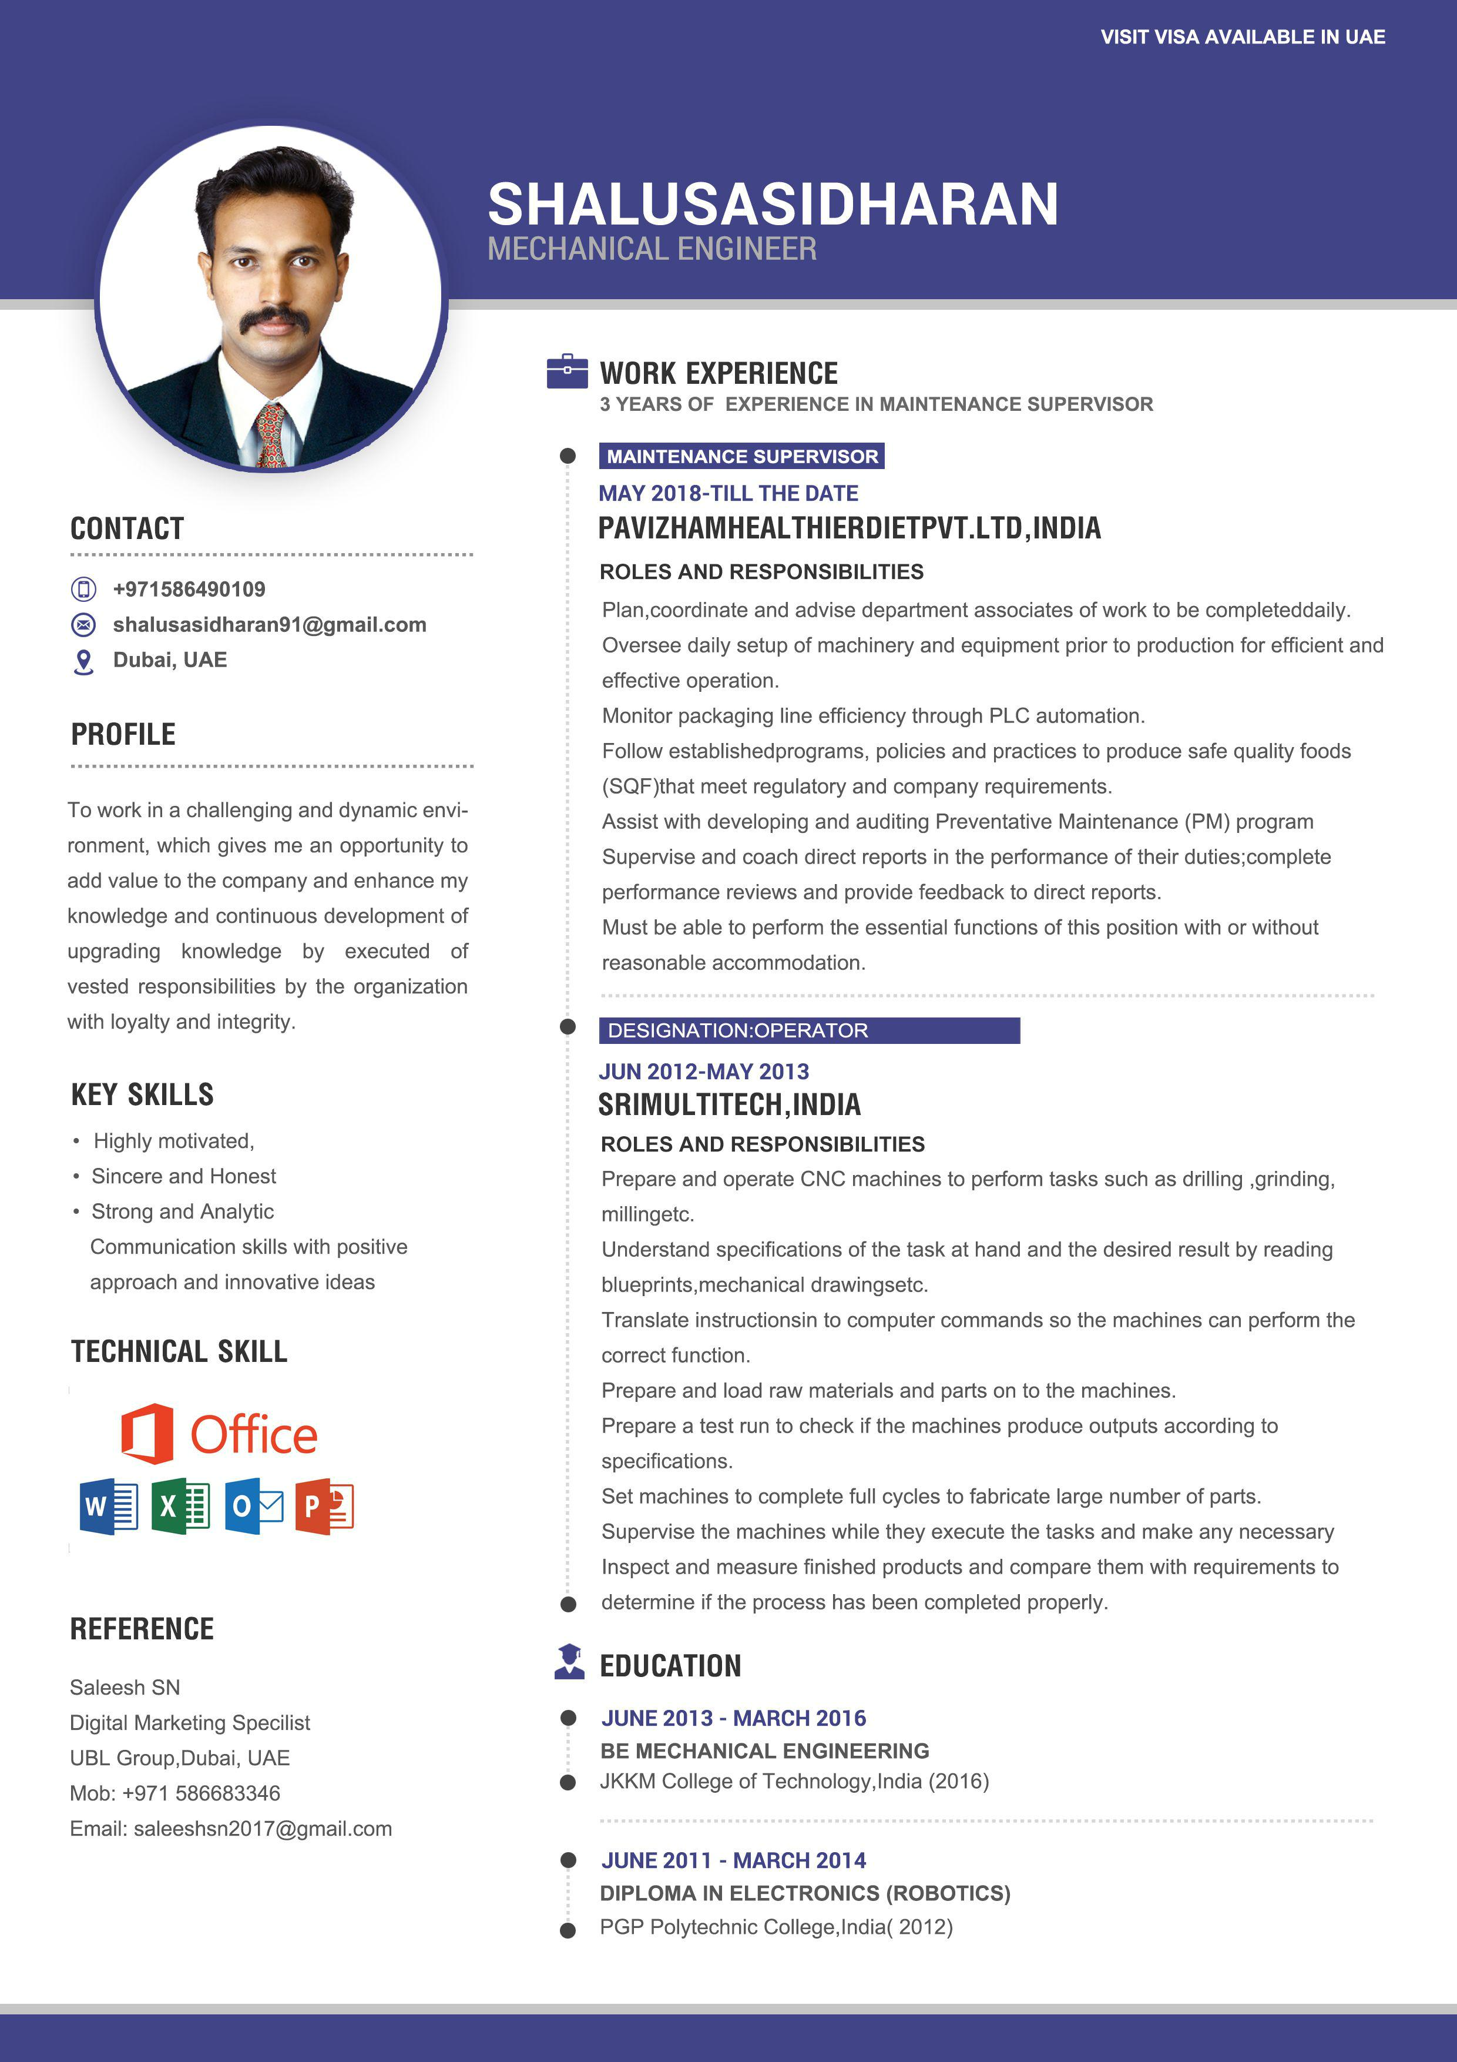

[Sasidharan-390086@2freemail.com](mailto:Sasidharan-390086@2freemail.com)

