CURRICULUM VITAE
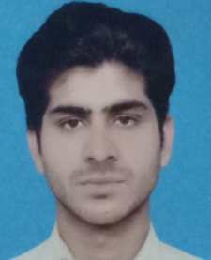
Samad

Email: samad.390092@2freemail.com
Site Engineer)

Profession:Civil(Site Engineer)

Objective:
To work honestly in your company for the planing,co-ordinating,supervision of technical aspect of construction project. My presence is vital to a construction project ,because they have a number of responsibilities including solving technical issues, providing advice, management and preparing reports.

Personal Information:

Date of Birth: 2nd April 1996
Religion: Islam
Marital Status: Single

Domicile: Khyber Agency

Academic History:

TenureDegree / Certificate Institute

2014 – 2018 B-Tech Civil Engineering Department of Civil Engineering
FROM
IQRA NATIONAL UNIVERSITY, PESHAWAR, KP
PAKISTAN

2011 - 2014 DAE in Civil Engineering Department of Civil Engineering
G.C.T Peshawar, KP PAKISTAN

2010– 2011 Matriculation (Science) THE BARA MODEL SCHOOL AND COLLEGE PESHAWAR
(BISE Peshawar),KP PAKISTAN

Experience:
Working with Dir Construction Company (DCC). I worked in this construction company as a Site Engineer from 5th October 2017 to till date at ZAVER PEARL CONTINENTAL PESHAWAR , a high-rise building located in Hayatabad Peshawar.

Technical/Computer Skills:

- MS OFFICE
- AutoCAD
- Typing
- Quantity Survey
- Land Survey

Languages:
  - English
  - Urdu
  - Pashto

