Vijay

Email: vijay.390105@2freemail.com

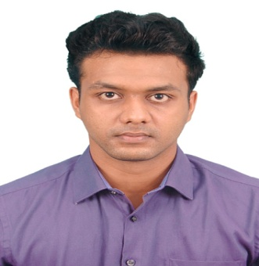

Career Objective
Looking for a position as a Service Advisor in dynamic environment where experience and professionalism are valued and required as means of attaining company success in strategy.
Professional Experience
Automotive Service advisor at Maruti Suzuki (ABT Maruti)_Period - June’17 to june’18

- Receive insurance & cash jobs of Body shop
- Take approval, open job card for new vehicle, arrange spare parts, delivering the vehicle
- Complete all related documents of insurance company, accident report and estimate copy.
- Take photos of vehicle at the time of opening job card.
- Prepare a complete and accurate estimate of cost for labor and parts.
- Serve as liaison between body shop, insurance and customers.
- Monitor the progress of each vehicle throughout the day and update customers frequently.
- Report all vehicles symptoms as described by customer.
- Inform to estimator if any additional damage found after dismantling, get new approved quotation from estimator.
- Manage and oversee the service center’s workflow and scheduling.
- Hand over the customer vehicle to workshop foreman with repair order and remain in touch with him to deliver vehicle timely.
- After finish repair on car checks the quality of work, if anything need to improve, send back
Vehicle inside workshop to repair or repaint in good quality.
- Take pictures after completion of work.
- Get signature on insurance subrogation paper and internal records paper as well.

Automotive Technician at TATA Motors (Kumaran Automobiles)_Period - July’16 to June’17

- Working as a car mechanic with various tools & machineries
- Knows oil& filter change for various car & car maintenance
- Computerized wheel alignment ,balancing & tire rotation
- Efficient and accurate work in accordance with dealership’s and factory standard.
- Maintain an organized shop area.
- Competent in explaining repair and maintenance needs to customers, aimed at helping them understand the important of both
- Continuous learn new technical information and techniques.

Educational Qualification
- B.E Mechanical engineering from Loyola Institute of Technology.
Anna University, Tamilnadu, India during Sep 2012-May 2016.

- Higher Secondary in St.Francis Higher Secondary School. Tamilnadu, India -2012
Certification
- Certified in NDT (Non-Destructive Testing) ASNT Level II as per SNT-TC-A-2011 - UT, RT, MT, PT, and VT.
- Certified for Quality Control in Welding.

Computer Skills
- AUTO CAD
- MS OFFICE

Personal Strengths
- Ability to work in a team and under pressure.
- Quick learner.
- Smart, Confident and Hardworking.
- Expressive Character of Leadership & Pleasing Mentalities.

Personal Details
Date of Birth : 28-Feb-1995
Nationality : Indian
Languages Known : English, Hindi, Tamil and Malayalam

