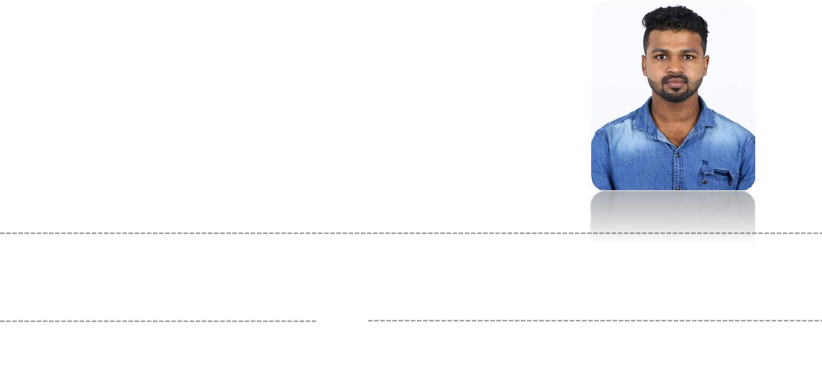
RAHIF

MECHANICAL ENGINEER

Email ID : rahif-390110@2freemail.com

A BOUT ME

Date of Birth: December 17, 1994

Age: 24

Gender: Male

Birth of Place: india

S KILLS

Leadership

Organized

customer relation

motivated

Accuracy &consistency

Design& Product Testing

AutoCAD

Revit 3D

CAREER OBJECTIVE

To work in any challenging environment to develop my skills, career and be a team player towards the growth of the organization with my Mechanical Engineering background. My aim is to develop my career to become a mechanical engineer.

ACADEMIC BACKGR OUN D

Royal college of engineering and technology thrissur kerala University of Calicut (20012-2016)

Bachelor of technology in Mechanical Engineering (B.Tech)

Completed Courses in Major:

MEP,HVAC ,Statics, Dynamics, Engineering Analysis, Mechanics of Materials, Fluid Mechanics, Dynamics of Machinery, Automobile ,refrigeration, Measurement and Instrumentation, Mechanical Engineering
Completed Project:

- Completed senior project at Royal CET,IR inspection controller

- Assisted engineering department in designing straight hand seamer used in bending, seaming and flattening sheet metal.

- Created models using SolidWorks and participated in cross-functional

PRO FICIEN T S KILLS

- Revit 3D Modeling Software Proficiency

- AutoCAD 2D Design Software Proficiency

- photoshop and Microsoft Office Proficiency

- Motor, Drive Train, and Bearing Analysis and Application

TECHN ICAL PROF ICIEN CIES

Autodesk, AutoCAD, Revit MEP, inventor, Mc quay duct sizer, HAP, heat load calculations, adobe Photoshop, MS Project, MS Office Suite (Word, Excel, Outlook, PowerPoint)

LAN GUAGE SKILLS

Malayalam

English

IN TERN S HIP

HVAC ENGINEER , 2018 – 2019 (BLUESTAR INDIA LTD Active innovative systems) Major activities of company are listing below

- Conducting meetings with client, architects, interior designers, civil contractors and clients in the field of construction.

- Heat load calculations, duct design , fixing machine configuration, cost estimation ,quote preparation ,quoting for Tenders, preparing installation testing commissioning and handing over work report .

- Conducting site visits and meetings, coordinating overall work making sure that work is going as per schedule.

- Supervising the projects.

- Collecting feedback and review from the client.

IN TERES TS

