KEY COMPETENCIES:

Customer Service

Operations Management Relationship Building
Communication Skills

After-Sales Management Well Organized
Detail-Oriented

Team Management Analytical Skills

PERSONAL DETAILS:

Date of Birth: 9th Oct 1975

Nationality: Indian

Marital Status: Married

Languages Known: English, Arabic & Hindi.

Driving License available for UAE, KSA, Qatar & India.
Farid
Email: farid.390241@2freemail.com
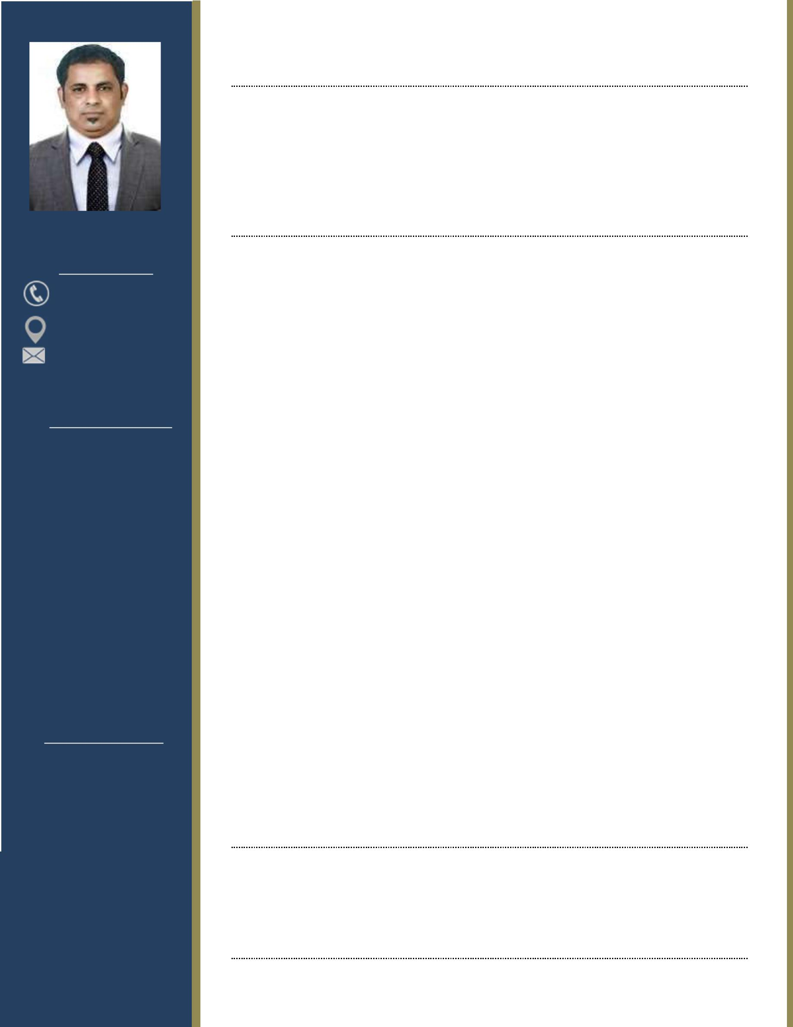

Customer Service | Operations | Store Management

OBJECTIVE

Highly enthusiastic customer service professional with 5+ years of experience working as a liaison between consumers and corporations. Skilled communicator and listener with a knack for remedying conflict, and keen organizational skills which allow for effective delivery of outstanding service. Maintain the highest level of integrity; dedicated to providing reliable and friendly service without ever compromising the reputation or competencies of the organization.

PROFESSIONAL EXPERIENCE

CUSTOMER SERVICE EXECUTIVE FEB 2014 – OCT 2018

Al Rafa Hotel, Jeddah, Kingdom of Saudi Arabia

Check and manage reservations done directly / on-line / or with booking agents.

Manage large amounts of incoming calls to provide all necessary information to customers. Manage, maintian and track stock used by house-keeping.
Keep records of customer interactions, recording details of inquiries, complaints, and comments, as well as actions taken. Follow up to ensure that appropriate actions were taken on customers requests.

Providing report to management on room bookings. Supervised the team in absence of Team Leader.

OPERATIONS COORDINATOR JAN 2010 – JAN 2014

Amwaj Catering Services, Qatar Petroleum, Qatar

Planning and Scheduling of staff, time-shifts, and assiging daily ROTA.

Coordinated with respective internal departments for their operations requirement and follow-ups for speedy resolutions withtin stipulated time.
Handled front office operations during events.

Responsible for managing the complete Order management processing cycle from Quotation to Invoicing.
Interface and follow up orders with suppliers, provide shipping instructions as per requirements.
Actively involved in managing the Return Material Process.

SALES COORDINATOR JAN 2007 – DEC 2009

Al Faiza Real Estate, Sharjah, UAE

Taking care of Property sales and preparing the necessary documents to complete the deal. Keeping track of renewals and handling maintenance requirements.

Maintaning relation with customers and handling their request or issues.

EDUCATION

HIGH SCHOOL COMPLETED (‘O’ Levels) – Cambridge Board | 1997
GRAMMAR SCHOOL, DUBAI – U.A.E.

I.T. SKILLS

Skilled at operating a computer & MS Office Suite.

Ability to create formal documents and presentations.

Usage of Tally accounting software for invoicing and managing accounts.

