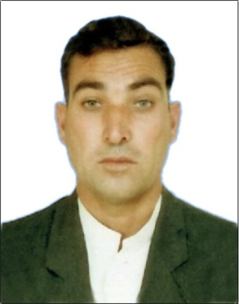
Curriculum-vitae

Arif

Email: arif.390261@2freemail.com

Applied Position for Land& marine surveyor

Job categories selected : Putting coordinate and lay out
Preferred job lactation : United Arab Emirates
Objectives
To obtain a position offering challenging responsibilities in a reputed organization requiring unwavering commitment towards profession and resultantly to become an integral part of the organization. I have great knowledge and experience in a land & Marine survey also can supervise the work also have experience in all computers operations.
Skills
- Experienced with the total station and level machine
- Proficient with windows MS Office
- Demonstrated strong analytical and problem solving skills
- Work very well as a team player and independent
- Fast learner and willing to master new information
- Academic Qualification
- Higher Secondary School Certificate from Pakistan

Diplomas
Civil Diploma : From TTB (trade testing board ) Peshawar
Pakistan
Computer Knowledge
MS Office : Quaid Azam institute Peshawar, Pakistan
Working experience:
More than 7 and a half years professional experience of land survey in oil and gas field travers calculation.

Duties and Responsibilities

- Area surveying
- Area Calculation
- Sitting out
- BM Shifting
- Traversing
- Topo Survey
- Tide Calculation
- Shifting the Level
- X Section
- Putting the Piles
- Putting the Sheet Piles
- Daily Report the work
- Using all kind of machine Skokie lieka and Topco

Total experience is 7years 6 months 2 year in Pakistan 2 years and 3 months in Saudi Arabia and 3 years and 2 months in united Arab Emirate

Experience in Pakistan :
Korcon LLC (Pakistan ) from September 2010 to September
2011
Experience in Saudi Arabia:
SadoonEst Dammam KSA from July 2011 to December 2011 Ali SumbleEst Dammam KSA from Jan. 2012 to Jan 2013 Saudi with con Dammam from Feb 2013 to September 2
UAE Experience :
Majestic Marine Engineering LLS Fujairah from July 2014 to September 2017
Post and fishing harbors development quay wall jetties and marinas break withers slipways beach protection system and other marine works
Projects:
1 Khalid lagoon majaaz bahrea Cornish Sharjah UAE
2 FEWA Pipe line installations Ras al Khaimah (shaam) UAE
3 Taweelah fishing port Taweelah (Abu dhabi ) UAE
4 Mina al arab Marina Ras Al Khama UAE
5 Al Maya Island Abu dhabi UAE
6 CPC Crown prance Curt Abu Dhabi
7 Jevel of creak (JOC)
Majestic Marine Engineering LLC Fujairah as a marine and land surveyor

