SINJU
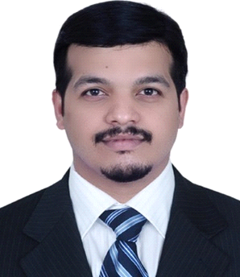
Teller/Cashier

Email: sinju.390339@2freemail.com

Objectives

To be a part of a dynamic organization, where the growth is interpreted not only in monetary and career progression but the essence should be driven in the form of mental and personal development

Work Experiences
Service Officer& FC cashier in UAE Exchange Centre L.L.C. in UAE from November 2012 to July 2018

- Foreign currency sales , purchase to and from customers and corporate
- Cross selling of currencies and allied products to meet monthly and yearly targets
- AML compliance scrutiny
- Cash handling, customer services, counting bulk cash, accepting transferred cash from other cashiers, branches and banks
- Keeping a close look on market currency fluctuation and manage booking of key currencies with for ex dept.
- Providing excellent customer service
- Day end report preparation and mailing.
- Reconciling of the files.
- Cross selling and marketing different allied products.
- Attending query from the customer
- Worked as a second line in Branch accounts
- Keeping a record of daily activities for future reference and audit purpose
ACHIEVEMENTS
- Employee of month ( Aug 2013,Dec 2014,Jan 2015)
- Special certificate for Outstanding Performance achievement in FC Business for the year 2014
Operational / sales Executive & Project Coordinators in Fast track Logistic Company in Riyadh on23rd April 2011 to 31st December 2011

- Preparing the documents of shipment &forwarding
- Involved in costing department and member of Planning Management
- Preparation of Payment and Outstanding Statements
- Briefing management with latest market changes to adopt new tools and techniques to become more competitive
- Constant follow up and strengthen company relationship with customer
- Understanding customer need and find solution to the query
- Purchasing the packing materials

Administrative & Purchase Executive in Administration Dept. in Ahalia Hospital Palakkad (01.09.2009-10.09.2010)

- Assist in the operations of Finance department
- Assist in the operations of HR department
- Assist in the operations of purchasing department
- Process the purchase orders by liaising with suppliers or principals
- Ensure all purchase are approved within mandated guidelines
- Assist in the sourcing locally and overseas for new goods not supplied by regular principals/suppliers
- Manage the local and overseas purchase enquiries

Technical Courses

- Completed course in MS Office.
- Completed in DCFA in G Tec Calicut (Peachtree, Daceasy, Tally, Wings)

Qualification

MBA (FINANCE& MKT) NIET (ANNA UNIVERSITY COIMBATORE) 2009

B.COM IT UNDER CALICUT UNIVERSITY KERALA 2006

Personal Details
Name : SINJU
Nationality : Indian
Birth Place : Kuwait
Date of Birth : 13th may 1985
Marital Status : Married
Driving License : Indian & UAE (Valid)
Languages : English, Malayalam, Hindi & Tamil
Visa status : Visit Visa

