CURRICULUM VITAE
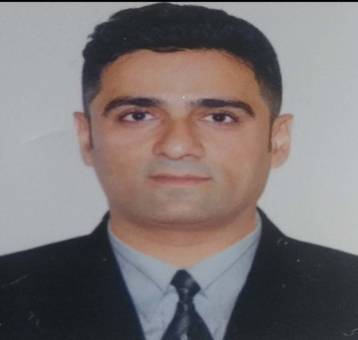
Vishnu
Email: Vishnu.390353@2freemail.com
OBJECTIVE
To be a valuable and reliable resource for leading organization that offers a sustained career in the field to aspire for opportunity to work on challenging projects and to enhance my knowledge and capabilities by working in a dynamic organization that prides itself in giving substantial responsibilities to new talents.

ACADEMIC QUALIFICATION
QUALIFICATIONS RESULT University Class Month, Year of Passing
HSC(Science) 56% GHSEB First Class March 1998
SSC 68% GSEB First Class March 1996
BE (TEX PROC.) 61% SCET, VNSGU First Class April 2003
Diploma in Export-Import 72% SGCCI Outstanding May 2004

COMUTER PROFICIENCY
MS Office, net surfing, soft communications and more.
EXPERIENCE
Worked for Textile manufacturing unit named V R Synthetics for 12 years in Surat, Gujarat, India. It was a wonderful experience to manage all the activities of the company and got the optimum results which was in the interest of the company. I was working here since 2007.
Worked as CHA (Clearing House Agent) for Two years. We were offering Custom clearing Services (Documentation, Filing,Custom fees, Liaison, Bank formalities, etc)for our clients to Export as well as Import of goods from India. I had worked in this field from 2005-2007.

KEY SKILLS
- Quick Learner
- Hard Working
- Proactive
- Detail Oriented
OTHER INTERESTS
- Reading
- Traveling
- Surfing Internet
- Music
PERSONAL INFORMATION
Date of Birth : 12th Oct 1980
Gender : Male
Languages Known: English, Hindi and Gujarati

