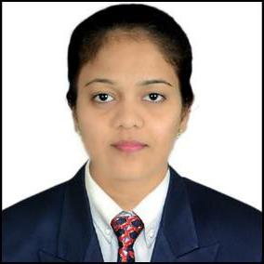
CURRICULAM VITAE

SUPRIYA
Email: supriya.390423@2freemail.com

CAREER OBJECTIVE

To Pursue Growth in my career with a Competitive and Challenging work Environment Which will Enable me to learn and Grow. Want to Emphasis on work life Balance and Build on my knowledge Acquired during the course of my Tenure. I will Grab every Opportunity and Aspect to Grow in my life.

EXPERIENCE

HDFC Bank Limited, THANE-MUMBAI, as a Assistant Manager From 15th December 2016 to 31st December 2018,
- Solving Merchant Grievances Regarding GST ( Good & Service Tax)

- Giving a proper and Quick revert on the Mail

- Help Merchant to Resolve the Issue over call

- Taking a feedback on the Services which was provided

- Giving the update or Information about New product to Merchants

EXPERIENCED IN FOLLOWING KEY PRODUCT

  ➢ M-POS
  ➢ AADHAR PAY
  ➢ SMART HUB
  ➢ PAYZAPP

KOTAK MAHINDRA BANK LIMITED, ANDHERI MUMBAI, as a Sales Executive From Nov 2014 to May 2015
- Handling the Outbound calls

- New credit card information given to customers

- Making the leads of credit cards

- Achieved monthly sale target

EDUCATIONAL PROFICIENCIES

- Completed Post Graduation in Master of Commerce in Advanced Accounting from Mumbai University in 2017-2018

- Completed Bachelor of Commerce from Mumbai University in 2015-2016

- Completed H.S.C from Bharat college of commerce & Science in 2012-2013

- Completed S.S.C from B.S Patil School in 2010-2011

CERTIFICATION ACQUIRED

- Well abreast with computers in MS Office (Word/Excel/PowerPoint)

- Typing speed is 30 WPM in Marathi

- Typing speed is 30 WPM in English

HOBBIES

- Listening Music

- Making glass paintings

PERSONAL DETAILS

- Marital Status : Married,

- Languages known : Marathi, Hindi and English,

- Nationality : Indian,

