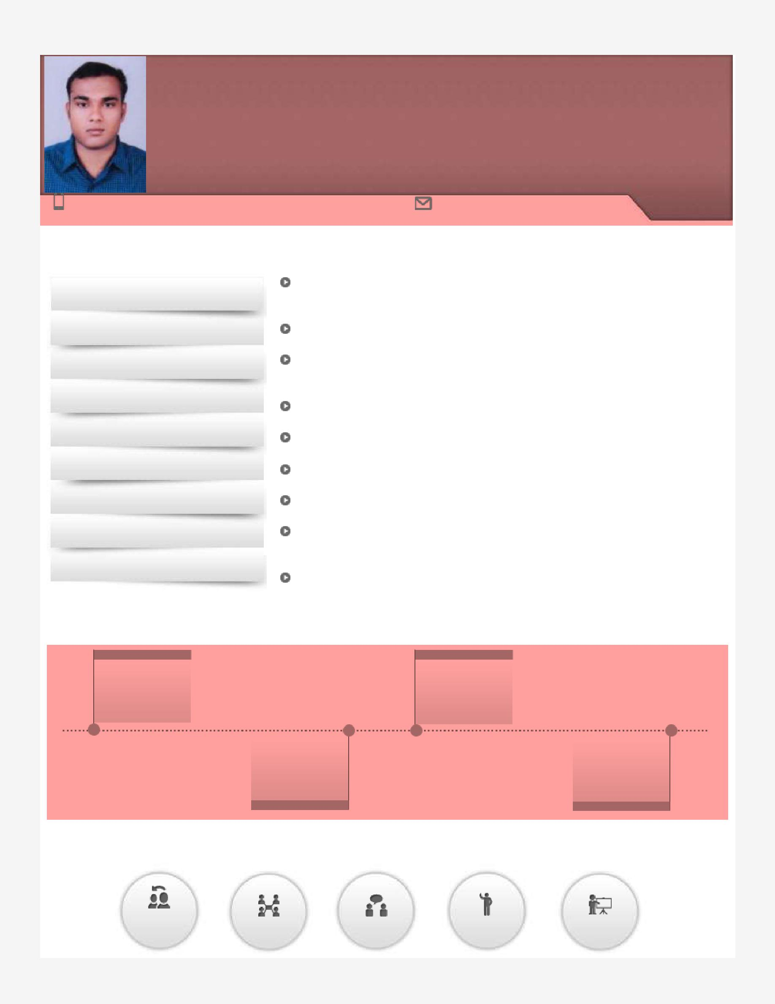
CYRIL
Quality Control / Production & Maintenance Operations

Mid-Level Professional
Cyril-390482@2freemail.com

Key Skills

Operations & Maintenance

Breakdown Maintenance

Process Improvement

Installation & Commissioning

Manpower Management

Production / Project Management

Health and Safety Management

Training & Development

Vendor and Supplier Management

Client Relationship Management

Timeline

Profile Summary

A competent professional with nearly 5 years of experience in coordinating, planning and implementing changes to technology, machinery and equipment, process methodology, direction of quality assurance & reporting procedures Skilfully managed terminal operation systems like OPUS TERMINAL, EMRCS, PROMIS and MAXIMO; nominated as PTIED reefer for client & made PTI Reports Experience in Production & Maintenance Operations, planning detailed activities through process engineering and finalizing requirements in consultation with Engineering and Production Departments to improve production operations Expertise in managing operations involving resource planning, materials planning, in-process inspection, and in coordination with internal departments Proven record in analysing and interpreting unique problems with a combination of training work experience and logical thinking to find the right solutions

Skills in conducting tests & inspections to ensure operational effectiveness of systems; planning & effectuating maintenance plans for equipment

Experience in managing overall maintenance operations for reducing breakdown / downtime and enhancing operational effectiveness of equipment

Capable of managing diverse range of activities such as execution of strategic plans, process & equipment management, capacity utilization, process control, cost management, audits & inspection and quality assurance

Completed Certification in QC from WQC Institute of NDT & Inspection Technology, Ernakulum

2015 till date | 2009-2013
DP World, Jebel Ali | B.Tech. in Mech.
FZCO as Assistant | from Institute of
Reefer | Engineering &
 | Technology
Project: Reliance | 12th from Holy
 | Angels Higher
Jamnagar – 3
 | Secondary School,
 | Kerala
2013-2015 | 2007-2009

Soft Skills

Change | Collaborator | Communicator | Motivator | Planner
Agent

Work Experience

Sep 2015 till date: DP World, Jebel Ali FZCO as Assistant Reefer

Responsibilities

Planning, implementing & monitoring technological changes to enhance productivity, managing operational profit for the region with proper control on delivery and production costs

Modifying equipment, process flow & working practices for controlling & reducing conversion cost per unit produced, ensuring optimum utilization of the available manpower/machinery

Monitoring quality systems & ensuring compliance with preset standards; troubleshooting issues and maintaining requisite documents to ensure complete in-process quality & improvement in process capabilities

Assisting in performing breakdown repairs to reefer container refrigeration plant to maintain the functionality of the equipment

Performing pre-trip inspection to reefer container to ensure the order is good for delivery
Conducting reefer monitoring duties at pre-determined intervals to ensure that all live reefer units are operating satisfactorily

Dec 2013 to Mar 2015: Project: Reliance Jamnagar – 3 (Client: Reliance Industries Ltd.) as Quality Control Inspector Responsibilities:

Conducted physical inspection of all piping / mechanical installations

Ensured all personnel is working in accordance with approved designs, international codes, standards and procedures

Provided guidance to contractor and witness all piping / mechanical testing and commissioning activities
Generated accurate, clear and concise inspection/QA/QC reports

Identified positive or negative progress including non-conformances and gave feedback to QA /QC Team Leader

Coordinated with contractors to ensure implementation of approved QA/QC procedures and the Quality Plan

Reviewed and approved method statements and inspection & test plans submitted by vendors and construction contractors
Managed welder performance test according to welding procedure specification and welder performance test data

Supervised the contractor in the compilation of the handover and test packs together with all as-built documentation

Trainings

Decos III g by Daikin industries LTD at Dubai

OPUS and PDA by DP World at Dubai
Professional training by starcool at Dpworld dubai

Professional training by carrier at Dpworld dubai

Education

B.Tech. in Mechanical from Institute of Engineering & Technology, Bundelkhand University in 2013 with 73% 12th from Holy Angels Higher Secondary School, Kerala State Board in 2009 with 60%
10th from St. George’s Mount High School, Kerala State Board in 2007 with 65%

Academic Project:
Title: Over Speed Indication and Automatic Braking System

Duration: 6 months

Other Course:

Completed Certification in QC from WQC Institute of NDT & Inspection Technology, Ernakulum, affiliated from ASNT, AWS, STED, ISEI, IIW, India

Description:

ASNT Level II Holder in Non-Destructive Examinations including Dye Penetrant Test, Radiography Test, Ultrasonic Test and Magnetic Particle Test

Welding Inspection approved by American Welding Society, affiliated to Scientific & Technical Education Council, Govt. of India Piping Engineering affiliated to Scientific & Technical Education Council, Govt. of India

Extracurricular Activity

Executive Member of National Cadet Corps and Event Organizing Committee in Bundelkhand University

