Indrani 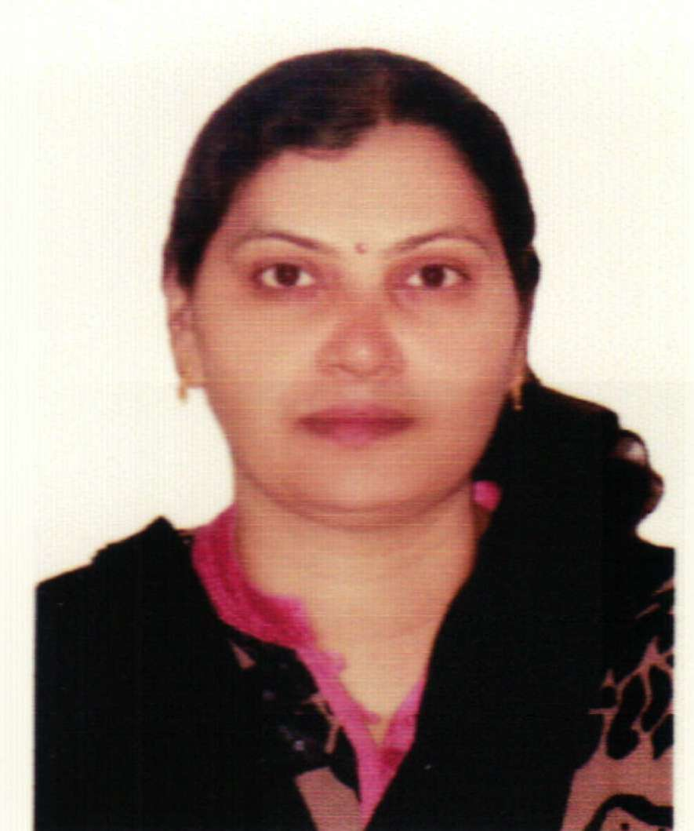

Email: indrani.3940488@2freemail.com

Synopsis : | - Seeking a position in Teaching / Administration, in an Educational Institution in Dubai.  - Possesses Masters in Science & Graduation in Education, with 10 years of Teaching & Administration experience in 6 reputed Schools in the Middle-East & in India.  - Focused on professional growth, utilizing the skills & abilities in Teaching& Administration, while being resourceful, innovative & flexible.
Education :  Qualifications :  Skills & Capabilities:  Experience : | - B.Ed. (Education) (2007, from SNDT University, Mumbai, India)  - M.Sc. (Botany)(1994,from University of Burdwan, W. Bengal, India)  - Teacher’s Training certificate (2007, Destiny Education, Mumbai, India)  - English Language Training certificate (2008, Oxford University Press, Mumbai, India)  - P.G. certificate in M.S. office (SCE, Mumbai, India)  - Expertise in delivering interactive Lectures while teaching the subjects Science& Mathematics in Schools, for the students of Std. V to Std. X.  - Adept at Administrative work in Schools, including Admissions, Counseling, Coordination with teachers & the parents, & Report card management.  - Expertise in Library management, including procurement, issues/return, cost control &improving the utilization of Library resources.  The Asian School, Kingdom of Bahrain (2012 – 2014)  Job profile as Teacher:  - Delivering lectures while teaching the subjects Science & Mathematics, for the students of Std. V to Std. X, & relevant Library management.  - Administrative work including Admissions, Coordination with teachers & the parents, to enhance effectiveness of education.  JH Ambani Petrochemicals School, Nagothane, India (2008 - 2011)  Job profile as Teacher:  - Teaching the subjects Science & Mathematics, for students of Std. V to VIII.  - Administrative work including Admissions, Report card management.  - Library management, including procurement, issues/return, cost control &improving the utilization of Library resources.  New Horizon Public School, Navi Mumbai, India (2007 - 2008)  Job profile as Assistant Teacher:  - Delivering interactive lectures while teaching the subjects Science & Mathematics, for the students of Std. V to Std. VIII.  - Administrative work includingCounselling of students, Coordination with teachers & the parents, for improved effectiveness of education.
3.. | Mahatma School of Academics & Sports,Navi Mumbai, India (2004 - 2006)  Job profile as Assistant Teacher:  - Teaching the subjects Science & Mathematics, for the students of Std. IV to Std. VIII.  St. Joseph School, Navi Mumbai, India (1996 - 1997)  Job profile as Teacher:  - Teaching the subject Science, for students of Std. VII to Std. IX.  A.G. Church High School, Navi Mumbai, India (1995 - 1996)  Job profile as Teacher:  - Teaching the subject Biology, for students of Std. XII.

Personal Information :

Date of Birth | 25th June, 1969 | Husband’s name / | Monilal
Gender | Female | Nationality | Indian
 |  | Languages known | English, Hindi, Bengali

