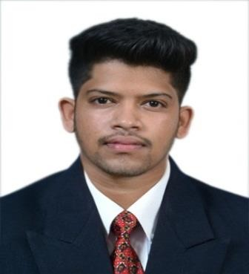
Curriculum vitae
Name: Henry
Email: henry-390496@2freemail.com

Objective:

To pursue my career in a progressive and professionally managed organization, this will provide adequate opportunities and environment to draw upon my knowledge, experience and clear strengths for mutual benefits.
Academic Details

- Passed Bachelors of Commerce (Bcom) from VVM. Shree Damodar College of Commerce and Economics Comba, Margao, 2016.
- Passed 12th STD from Multipurpose Higher Secondary School Borda, Margao, 2013.
- Passed 10th STD from St. Thereza Convent High School Ganapoga, Raia, 2011.
Key skills

- Computerised Accounting with Tally ERP 9, Busy 14, Sage 50.
- Internet and E-Commerce.
- MS – Office (Word, Excel, PowerPoint, Access, Advance Excel).
- Good Communication Skills and leadership skills.
- 4 wheeler and 2 wheeler driving licence (India).
Work Experience
Company: Quadros Motocorp Co. Location: Margao , Salcete, Goa Working Experience: 1 year 5 months Designation: Sales Consultant
Work Profile:
  - Involves sales and marketing activities for Piaggio Vehicles PVT LTD.
  - Responsible for RTO (Regional Transport Office) work.
  - Quality check of vehicles.

  - Supervision of PDI (Pre Delivery Inspection).

  - Updating of CDMS (Customer Dealer Management System).
  - Deposition of Cash in banks and handling of cash.

Company: Savio and Grace Sons Realtors and Developers.
Location: Raia , Margao , Salcete, Goa Working Experience: 8 months Designation: Office Administrator Work Profile:
  - Handling external or internal communication.
  - Handling Accounts and handling of cash.
  - Marketing of Real estate.
  - Responsible for TCP(Town and country planning) work.
  - Coordinating with architect, survey department, Bank etc.
  - Supervision of construction site.

Personal Details

Languages: English, Konkani Age : 24 and Hindi.

Gender: Male Marital Status: Unmarried
Nationality: Indian Date of Birth: 17/10/1995

Hobbies: Drawing,
Playing Badminton, Football.

