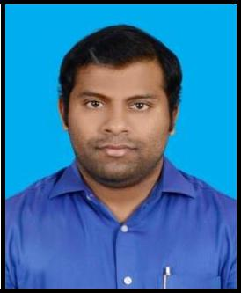
SHEBY
Sheby-390509@2freemail.com

Objective Seeking a career that utilizes my knowledge and gain comprehensive understanding for a reputed organization so as to take responsibilities and contribute my strength significantly.

Skills & Abilities Performance Evaluation, Communication Skill, Willingness to learn new jobs, strongly self-motivated, MS-Office (Word, Excel, PowerPoint), IT Credentials (Windows XP, Windows 7, Windows 8, Windows 10) and Tally.

GCC Driving License

Experience Since 14 March 2019
Assistant Accountant Majan International Petroleum Service – Ghala, Muscat
- Handling Day to Day jobs of Accounts Department and Banking.

- Preparation of Cash and Bank Vouchers, Sales Invoices, Delivery Note, LPO, Quotations and Stocks.

- Coordinating with Client and Overseas Suppliers for procurement of materials as per specifications.

Since 06 August 2017 to 03 March 2019
Assistant Accountant Technical Works – Al Khobar, Saudi Arabia
- Handling Day to Day jobs of Accounts Department.

- Preparation of Cash and Bank Vouchers, Sales Invoices, LPO, Quotations and Stocks.

From 04 May 2016 to 30 June 2017
Sales Co ordinate, International Timber Co. (ITCO) Dammam, Saudi Arabia
- Preparing sales order, delivery note and invoices.

- Assisted Regional Manager for the preparation of MIS Reports and Email Communications

- Preparation of Cash and Bank Vouchers, Sales Invoices, Purchase Vouchers.

- Handled Procurement department for acquiring best price for the materials and preparation of LPO.

- Assisted Logistics Department to finalize the Purchase orders and receipt of materials at store.

- Co ordinated with Sales Department for the finalization sales orders and Delivery of Materials.

Education Noorul Islam University – Kumaracoil, Thucklay, Tamil Nadu, India – Master of Business Administration

2013 - 2015
In Finance (Main) and Human Resources. CGPA – 6.00

Bharata Mata College – Thrikkakara, Seaport Airport Road, Kerala, India - Bachelor of Commerce. 2008 - 2011

International Indian School – Dammam, Saudi Arabia – 12th Grade 2007 - 2008

In Commerce and Computer Science

Personal Details Date of Birth : 14th April 1989
Religion : Christian

Nationality : Indian
Gender : Male

Languages : English and Malayalam
Hobbies: Composing Music, Singing, Playing Musical Instruments (Keyboard and Drums),
Video, Audio and Photo Editing and Playing Basketball and Badminton.

2

