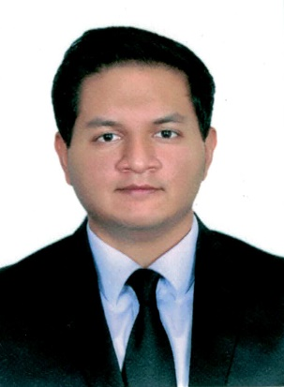
Peter

IT specialist

Email: peter.390618@2freemail.com

About Me
I am an experienced IT specialist with a Master’s degree in software application development. I like learning new technologies, building websites and mobile apps.

EXPERIENCE

Software Developer
JULY 2017 – NOVEMBER 2018:
Remote Software Solutions Pvt. Ltd.,
H.No.1661, Near Tarun Bharat, Alto Betim, Penha de Franca, Goa.

Document Management System – Developing a document management system with features of document workflow processing, user management control and features of Scanning, OCR recognition, barcode recognition using an SDK.
Technologies used: .Net framework (windows forms, .net API, mvc 5 with 3-layerarchitecture and a windows service)

Software Developer
JULY 2015 – JUNE 2017:
Presentsoft Technologies Pvt. Ltd.,
Canca, Mapusa, Goa.
- Pharmacy Store Application – Developed the Angular admin module and part of the API. The admin panel was developed with Angular JS and the API was developed with ruby on rails. The RESTful API connects to the admin panel and an Android app.
- Project management System – Modified this Ruby on Rails project by making changes to the user interface and fixing some bug issues.
- WordPress Plugin – Modified this plugin to add more fields to the search form.
- JavaScript Music Application – This project used a JavaScript library (vexflow/vextab) to play music notes. It was developed with HTML, CSS and JavaScript and deployed with node Web kit and Cordova to various platforms.
- Admission System – A small project to handle online admission of students to a college in Goa. Statistical analysis of all students can be viewed, a payment ledger can be maintained and pdfs to generate reports and forms.
- School Technical Support – Provided technical support to a school on Ubuntu OS. E.g. transferring software which was installed by the terminal from one computer to another without internet, making a bootable USB, etc.
- Company website – Worked on Improving the current company WordPress website.
- Email app – This app was done with Ruby on Rails to store the emails offline and forward it automatically. It is a module of a bigger project.
- Biometric device - I worked on developing a new software with the SDK provided. The software was being developed in C# with Xamarin Studio. At that time, I tested and researched the Arduino board with its fingerprint reader. Also performed Installation, troubleshooting, repair, and maintenance of an existing fingerprint reader software to a product manufacturing plant in Verna, Goa.
- Employee management system – A statistical app to show data and statistics of employees. It is done using php with Symfony framework.
- Test Automation System - A testing software that is integrated with multiple devices. I fixed few bug issues.

Software Developer
JANUARY 2015 - MAY2015:
Internship at Presentsoft Technologies Pvt. Ltd.,
Canca, Mapusa, Goa.
- Continued Development on a RoR (Ruby on Rails) Application for a housing society. It had integrated features of subdomains for each society, Organizing meetings, multiple users, track bill records and a few other features.

Freelancing projects:
- Marine Survey website (agapemarine.com) – Implemented design, development and hosting for a staticphp website with a contact form. Using the Cpanel provided by the hosting server providers, I provided theclient with a company email system.
- School website (Wiz skool old website) – Developed a static php website with a contact form. The site designwas explained verbally and the FTP details were provided by the client for hosting.

EDUCATION

Master of Computer Applications

Assam Don Bosco University, Azara, Guwahati 781017, Assam.
MAY 2012 - APRIL 2015
CGPA: 7.35 / 10

Bachelor of Computer Applications

Don Bosco College (Goa University), M.G. Road, Panaji, Goa.
MAY 2009 - APRIL 2012
CPI: 6.20 / 10

