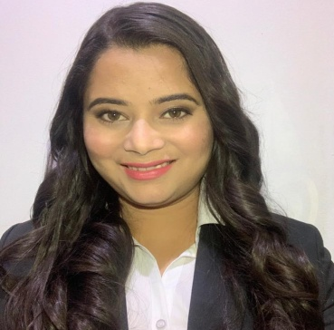
Pari
Email address: pari-390932@gulfjobseeker.com

Career Objective
Seeking to obtain employment in a progressive establishment in order to apply my abilities, skills and experiences to develop and hone my fullest potential as a professional for continued personal growth and professional advancement. I am looking for a challenging career which suits the best of my professional abilities and for more responsibility and a position in a more ambitiousindustry.

Key Skills
- Effective Communication Skills | - Effective Computer and Internet Skills
- Time Management | - General Customer Service
- Cashiering | - Restaurant Booking Management
- Great Interpersonal Skills | - Food & Beverage Industry Knowledge
- Problem solving and analysis | - Detail Oriented

Professional Experience

Café in
President hotel
F & B Supervisor,(july 1st 2019 to till)

Restaurant in
Dubai UAE
F & B Hostess (26th October 2017 to June 2019)

Hotel
Al Barsha, Dubai UAE F
& B Hostess (March 2017 – October 2017)

Food Court
Mohali, India
F & B Hostess (June 2016 – February 2017)

Restaurant
Mohali, India
F & B Hostess (September 2015 – May 2016)

Key Deliverables:
- Reporting directly to the manager.
- Greeting & welcoming guests
- Directing guests to their designated tables
- Arranging table reservations for guests
- Taking orders, serving, bussing in & out tables.
- Creating and completing necessary end shift reports.
- Ensuring to meet the needs of the guests
- Ensuring the cleanliness of all areas before the start of operation
- Accurately answering guest inquiries through phone and personal.
- Collecting feedbacks from departing guests for the improvement of the establishment.
- Answering incoming calls to the restaurant and provide appropriate service.
- Tend to special guest needs and requests.
- Observant to guests’ needs throughout dining experience to ensure they receive high quality service.
- Help dining room staff by setting and clearing tables; replenishing water; serving beverages.
- Contribute to team effort by accomplishing related results as needed.
Academic Qualifications

- Diploma in Hotel Management and Catering Technology
Anna Malai University
Chennai, 2011

- Passed 12th from HP Board in 2013
- Passed 10th from HP Board in 2010

Personal Details

- Name: Pari
- Birth Date: 29th July 1992
- Age: 26 years old
- Height: 5’4’’
- Weight: 65 kg
- Sex: Female

I do hereby declare that all the information given above is true and correct with the best of my knowledge.
___________________________
PARI
Applicant

