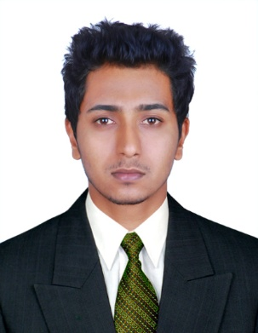
Resume

Dony

E-mail Id : dony-391198@2freemail.com

OBJECTIVE:
Seeking a position of responsibilities that utilizes my skills and experience and keen to work in an environment where I can enrich my knowledge

PROFESSIONAL EXPERIENCE ( 6 Years ):
Employer: Al Reem Hospico L.L.C, Al Ain, Abu Dhabi, UAE. SEHA – Ambulatory Health Services (AHS) Abu Dhabi Project
Job title: Biomedical Engineer
Start Date: 28 December 2014
Duties and Responsibilities:
- Maintenance and troubleshooting of Critical care, Laboratory, Dental and other medical equipments clinically as well as technically.
- Handling technical & operational activities of installing biomedical equipments.
- Preparation of documents for JCI and HAAD accreditation.
- Coordination with service personnel of various medical equipment companies.
- Perform Preventive maintenance and calibration of medical equipments.
- Perform electrical safety tests on biomedical instrumentation using test equipment.

Employer: Lakeshore Hospital and Reserch center, Kochi, Kerala, India.
Job title: Biomedical Engineer
Start Date: 03 December 2012
End Date: 03 January 2015
Duties and Responsibilities:
- Preventive Maintenance, breakdown calls, Installation & Demonstration and calibrations of all medical equipment’s.

Employer: Amrita Institute of Medical Science and Research Center Cochin, India.
Job title: Trainee staff
Start Date: 03 April 2012
End Date: 29 October 2012
HANDLED EQUIPMENTS
Handling Equipments like Ventilator,Anesthetia machine,Radiology equipments, Defibrillator, Physiotherapy Equipments, ECG Machine,CTG machine,Stress Test Machine, Spirometer, ICU Monitors, Syringe pumps,Infusion pumps,Fetal doppler, Audiometer, ENT unit, Electrocautery , Centrifuge, Refrigerators, Dental chair, Autoclave,Dental x ray,Dental x ray sensors,Various other general and dental equipments,etc.

EDUCATIONAL QUALIFICATIONS:

Bio-Medical Engineering (2008-2012) from Sathyabama University, Chennai, India.

SKILLS:
- Excellent interpersonal skills and knowledge of health-care industry
- Proven ability to install, repair and maintain biomedical equipment’s.
- Actively worked on document management of all the equipments of hospital comes under Biomedical Engineering during the audit of JCI and HAAD Accreditation.

Experience in the usage of different types of Test and Calibration Equipment’s
- Proficient in MS Word and Excel

PERSONAL PROFILE:

Date of Birth : 22-05-1990

Nationality : Indian

Marital Status : Single

Sex : Male

Languages Known : English, Hindi, Malayalam, Tamil
Driving License | : | Valid UAE driving license

