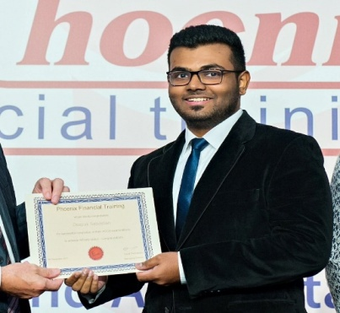
Personal Details
Name : Deepak
Email : Deepak-391225@gulfjobseeker.com

Career Objective
A dedicated, passionate and innovative individual offering a strong educational foundation in accounting, finance, audit, management accounting, complimented by the ability to adapt for new projects and environments.
Being motivated and versatile, seeking for an internship or a full time opportunity to utilize my acquired knowledge and skills.

Capable of self-development in many areas. Capable of working in a team in order to produce quality results for the organization. Looking forward to contribute my skills and knowledge to the hiring organization/firm to help drive growth and sustainability and to also achieve its financial goals and objectives.

Personality & Character
- Excellent communication and presentation skills.
- Pleasant, honest and calm personality.
- Extremely punctual and capable of working under pressure as well as meeting deadlines.
- Persistent with a strong desire for success in all areas.
- Pays attention to detail and possesses high analytical skills.
- Reliable and ethical individual.
- Always interested and willing to continuously learn and improve.
- Proficiency in computer skills such as Microsoft Excel, PowerPoint and Word.
- Excellent knowledge in accounting finance and Management Accounting
Work Experience
Chartered Accountants – Kerala, India
Accounts & Finance Intern – (June 2017 – August 2017)
Duties and Responsibilities
- Participated in firm and individual audit involving vouching of ledgers, documentation and file management.
- Preparation of Financial Statements (i.e. Balance Sheet, Profit & Loss with accompanying schedules)
- Preparation of Accounts in Tally.ERP 9

Academic Qualifications & Education
- Diploma in Accounting and Business awarded by the ACCA (the Association of Chartered Certified Accountants) which is based and headquartered in the UK. It consists of more than 200,000 members and 486,000 students. It is a chartered qualification and is considered a professional course.
- Advanced Diploma in Accounting and Business awarded by the ACCA.
- BSc. (Hons) degree in Applied Accounting awarded by Oxford Brookes University.
- Completed the ACCA professional qualification from Phoenix Financial Training, Dubai.
Knowledge | F1 | Accountant in Business - Completed
 | F2 | Management Accounting - Completed
 | F3 | Financial Accounting - Completed
Skills | F4 | Corporate and Business Law - Completed
 | F5 | Performance Management - Completed
 | F6 | Taxation – Completed
 | F7 | Financial Reporting – Completed
 | F8 | Audit and Assurance – Completed
 | F9 | Financial Management – Completed
Professional Level | P1 | Governance, Risk and Ethics - Completed
 | P2 | Corporate Reporting – Completed
 | P3 | Business Analysis - Completed
 | P4 | Advanced Financial Management – Completed
 | P5 | Advanced Performance Management - Completed

- Grade 12 (Commerce) from Our Own English High School, Sharjah, UAE, CBSE board with 82% in 2014. Subjects included English, Business studies, Economics, Entrepreneurship & Accountancy.

Extra Curricular Activities And Hobbies
Participated in Inter-School sports activities mainly football and basketball.
Hobbies include reading, exercising & listening to music.

Other Details
Nationality: Indian
Date of Birth: May 2nd, 1996
Languages known: English, Hindi & Malayalam
UAE Driving License: Yes

