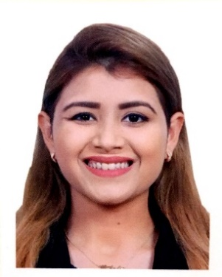
Shania

Email: Shania.391281@2freemail.com

Objective
Action-oriented sales representative seeking an opportunity to utilize skills in initiating and developing strategic relationships with government agencies, nonprofit organizations, and industry.

Voluntary EXPERIENCE
- Sub-editor, The Central School, Dubai, TCS Magazine
June 2015 – July 2015
- Responsible for all elements of planning, story development, editing and production.
- Edited, fact – checked and styled articles, columns and news brief columns; complied or wrote editorial departments.
- Ensured all written content in the magazine conformed to the style and editorial positioning of the magazine.
- Fully responsible for the accuracy of all facts printed in the magazine; brought any potential legal problems to the attention of the editor.
- Worked quickly and effectively under pressure to tight deadlines, created headings, photo captions and intros appropriate for magazine editorial style.

- Volunteer, CMTC Global
August 2016 – August 2016
In 2016, I joined the CMTC Global because I wanted an opportunity to do something that would benefit others as well as a self-learning process. This was a one day’s experience of personal growth, team building, leadership, and building relationships with outbound office company staff.
In this role I:
- Engaged in positive and supportive relationships with core members through sharing daily life experiences together.
- Ensured that physical, emotional, spiritual, vocational, recreational, health and safety members were met.

- Information point volunteer, Atlas Educational Institute for event Breast Cancer Awareness

October 2016 – October 2016

- Visiting the information point at regular intervals.
- Keeping the visiting point well organized and stocked
- Reporting problems

work experience
- Operations Officerat
- To handle customer/ applicant’s queries via email, telephone or direct.
- To follow the procedures required for document scrutiny & collection for visa processing.
- To manage administration & logistics of passport delivery to all concerned limits; consulate, applicant, logistics, company etc.
- To promote & sell optional services& aware of the use of POS.
- To maintain & record all applicant’s data confidentially.

Education
- BTEC LEVEL 3 in BUSINESS ADMINISTRATION with Distinction, Distinction, Merit from the International College of Business Administration & Law (2016-2017)
- IELTS Academic Test with a score of 6.5
- MS OFFICE ADVANCED Computer Qualification

Awards and Acknowledgements
- School Magazine Editor in 2015
- Participated in General Knowledge Quiz Competition by Knowledge Quest Edu Expo in 2016
- Participated at careers@Hilton at the Hilton Garden Inn, Al Barsha, Dubai UAE

SKILLS
- Demonstrated ability to work efficiently with others and communicate effectively with a variety of people, including event managers and peers.
- Self-motivated and seeking for a challenging career to grow with experience.

Personal Dosseir
Date of Birth: 04 April 2000
Marital Status: Unmarried
Driving License: UAE national license
Languages: English & Hindi (Verbal & Fluent)

