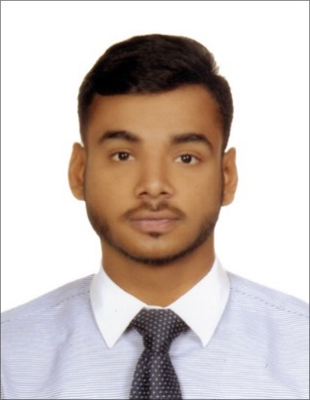
NATHAN

Email: Nathan.391282@2freemail.com

OBJECTIVE
To pursue my career with a reputed and prestigious financial institution, where I can utilize my skills, talents and education background to the maximum towards the goals of the company.

VOLUNTARY EXPERIENCE
- Volunteer – Papal Visit with Vibe Events
February 2019
- Manage all activities at the Team Check-in table.
- Provide assistance, directions and information to the attendees as well as hand out and collect registration materials.
- Facilitate smooth pedestrian traffic flow from the parking area to the registration area.
- Assure that only authorized general and VIP ticket holders are admitted to the designated area.
- Volunteer – Fun Run DP world with Sky High Events
March 2019
- Providing a warm, friendly welcome to all participants as the public face of the event.
- Coordinating and supporting the work of volunteers.
- Organizing/ handing out goodie bags.
- Assisting the runners and providing race information.
EDUCATION& TRAININGS
- BA Accounting & Finance from Middlesex University, Dubai (2016-2019)
- Passed high school education from Gems Our Own Indian School, Dubai (2015-2016)
- SAGE Software, Microsoft Office 365, Windows, Hyper Text Markup Language (HTML), and Adobe Photoshop
AWARDS& ACKNOWLEDGEMENTS
- Inter-house Graffiti competition at Gems Our Own Indian School, Dubai (2015)
- Inter-house Mime competition at Gems Our Own Indian School, Dubai (2015)
- Higher secondary group dance winner (2014-2015)
- Participated in a play and dance for the Catholic Youth Conference at St Anthony of Padua Church, RAK (2018)
- Promoted the ‘World Youth Day – 2019’
SKILLS
- Excellent professional communication, leadershipand interpersonal skills
- Goal oriented and seeks new challenges
- Critical thinking
- Team player
- Creative
- Positive attitude and flexible
PERSONAL DOSSEIR
Date of Birth: 13th January 1999
Marital Status: Unmarried
Driving License: UAE Driving License
Languages Known: English, Hindi, French, Marathi and Urdu

