Resume
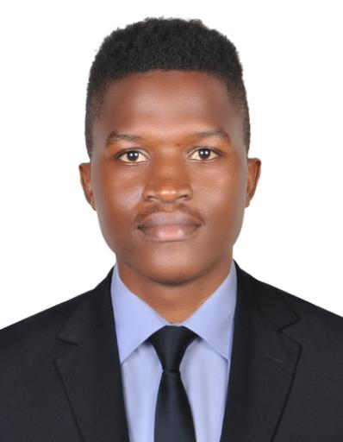

Ibrahima

Email: ibrahima.391316@2freemail.com

Objective

High energy room Service and attendant focsed on promoting customer satisfaction through exceptional service and maintaining outstanding hotel accommodations. Tech-savvy, highly accurate, and efficient with cleaning and general housekeeping operations. Exceptional people skills with down-to-earth, outgoing personality.

Education

Course | Institute/Board | Year of Passing | CGPA/Percentage
Electrical | Standard college Of | 2017 | 8.5
engineering | Technology
Standard
CPR/AED And | National heart Foundation | 2019 | 9
First Aid

Experience

- Marocana (10/06/2019 to 02/06/2019) Room Attendant And cleaner

Role & Responsibility:Worked as a room attendant and cleaner

Skill

-Excellent communication skills in verbal and written both.

-High tolerance power with remarkable patience.

-Possesses great stamina and fitness.

-Reliable, polite and generous

Achievement

1. Got the best employee of the year in 2018

2.Was praise by my former employer as the most effective and respectful employee

Strength

- Self-motivation, initiative with a high level of energy.

- Verbal communication skills.

- Decision making, critical thinking, organizing and planning.

- Flexible to different situations.

- Quick Learner.

Interests

- Reading novels.

- Listening music.

- Play outdoor games

- Solving Puzzles.

Personal Details

DOB:01/09/1991

