Nisha  (Pharmacist - DHA) | nisha-391351@2freemail.com
About Me  - Skilled pharmacist with exceptional organization skills, strong interpersonal communication ability.  - Extensive knowledge of medications and their use.  - Experienced pharmacist places a strong focus on attention to detail and excels in accuracy to guarantee patients are cared for and prescribers have confidence.  - Dedicated professional ensures that all safety protocols and security measures are adhered to in meeting the high standards of the field.  - WORK EXPERIENCE  Institution Position Duration  KERALA STATE CO- OPERATIVE CONSUMERS FEDERATION LTD REGISTERED PHARMACIST 17.01.2008 to 20.01.2019  - RELATED EXPERIENCE  - Excellent communication and active listening skills to ensure that patients and customers understand their medications and how to take them.  - Extensive education and training to guarantee that I am constantly up to date on the newest research and information regarding medications.  - Ability to hear and understand what others are saying, and oral expression skills that allow me to explain a complicated topic in a simple way that they can understand.  - Strong sensitivity to problems that may arise when issues with prescribers, patients or drug companies are present.  - Intense focus and attention to detail to minimize mistakes and unnecessary expenses for both the drug companies and the pharmacy.  - Exceptional social perception, facilitating the understanding of concerns and issues of both patients and prescribers as they arise.  - Instructing skills that allow me to teach others how to do things better rather than just doing jobs for them.  - JOB RESPONSIBILITIES  - Dispense the OTC drugs, nutritional supplements, minimartproducts, medical equipments after understanding the exact needsof the customer.  - Advice patients about general health topic such as diet , exerciseand managing stress and on other issues, such as what equipmentsor supplies would be best to treat a health problem.  - Complete insurance forms and work with insurance companies toensure the patients get the medicines as they need.  - Performing daily basis handing over and taking over for controllingsubstance.  - Promotions of currents offers and discount policies pharmacy.  - Merchandising the goods received to the pharmacy.  - Monitoring of accountability. Focus on Expiry & non-movingstoke.  - 100% Product availability. Daily monitoring the vital drugs.  - DECLARATION  I NISHA S DHARMAN declare that the above mentioned details are correct to the best of my knowledge.  NISHA S DHARMAN. |  | 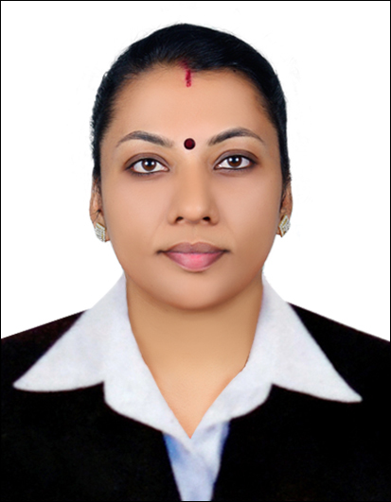  D.O.B  - 06 - MAY - 1987  Visa Status  - Dependent Visa (Husband)  Nationality  - India  Marrital Status  - Married  Languages  - English,Malayalam,Tamil, Hindi  Professional Education  - Deploma in Pharmacy (2007)  Board / University  - Board of D.Pharm Examination (Govt.of Kerala)  Accademic Education  SSLC (2002)  Board / University  - Board of Public Examination, Kerala, India  HSE (2004)  Board / University  - Board of Higher Secondary Examination, Kerala, India  Professional Licence:  - Registered Pharmacist–Pharmacy Council, Kerala  Reg No - 35224  Date –28/12/2007  - DHA Eligibility No–DHA/LS/12112018/860810 ,  Dated: 06/01/2019  Skills  Fast Learner  Effective Communication

