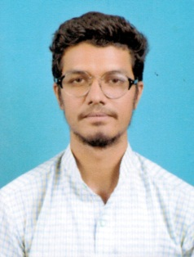
SAIF

Email: saif.391435@2freemail.com

- Academically astute individual offering in-depth academic knowledge
- Self-motivated, hardworking and goal-oriented
- Creative, Resourceful, committed and an optimist
- Result oriented individual with strong analytical and interpersonal skills and a quick learner with high levels of adaptability and ability to take initiative.
- Good communication skills, verbal & written
- Excellent Presentation Skills
- An effective team player with good planning and execution skills
- Systematic approach

CAREER OBJECTIVE

To work in an environment where I get a chance to gain knowledge which can be shared and enriched, where I can utilize my skills and expertise to the optimum towards achieving my goal.

WORK EXPERIENCE

PREMIER CADD TRANING SERVICES(freelancing/part time) :-
- Job Profile:Joined the company as a Marketing Executive, I was a part of the company from 10th May 2016 till12th December 2016.

TOUCH BUIZ (EVENT’S & PROMOTION’S):-
- Job Profile: Joined the company as a Graphic Designer on 13thMarch 2014 till March 12th 2019.
- About the Job:Design as per costumers requirements, maintaining quality relation with the consumers, representing my team.

STRENGTHS

- Good communication skills and professional demeanor.
- A creative, well-organized and enthusiastic individual with a flexible approach to work.
- Recognized for reliability and “getting the job done” through persistence and strong work ethic.
- A willingness to learn and a problem solving approach (Quick learner).

EDUCATIONAL QUALIFICATION/ ACADEMICS

S.S.L.C:Adhyayan central school, Dr. Raj kumar road, shakthinagar,Government of Karnataka

DIPLOMA (Mech):Vidya Vikas polytechnic, Bannur road, Mysore.
Board of technical Education

TECHNICAL SKILLS

- Training: Basic of Computers, MS-Office all versions
- Training: AutoCAD , CATIA V5, REVIT, Coral draw, Photoshop, basic illustrator knowledge
- Completed a Software course in above given software’s.
- Communicating with the consumer with fluency.
HOBBIESAND INTEREST

- Cricket, Listening Music, Football, Travelling, swimming,sketching, graphic designing.
LINGUISTIC KNOWLEDGE

- English, Hindi, Urdu & Kannada

PERSONAL DETAILS

Name : Saif
Date of Birth : 30th April 1995
Sex : Male
Nationality : Indian

