Sarath

Contact Details:
E-mail:
sarath-391443@2freemail.com

Date of Birth:
Nov 04, 1994

Marital Status:
Single

Visa Status:
Visit

Languages Known:
English, Hindi, Malayalam

Nationality:
Indian

OBJECTIVES
To effectively apply myself in a professionally challenging environment in a manner that positively benefits the organization’s goals and objectives and contributes toward my career development.
Education | University/Institution | Year
B.Com (Finance and Taxation) | MG University | 2013-2016
12th Kerala state board | Jerusalem Mount Higher Secondary School | 2013
10th Kerala state board | St. Berchman's School | 2011
EDUCATION
EXPERIENCE (3 YEARS)
Worked as Accountant in HOTEL KINGS WAY (May 2016 to March 2019).
PROFESSIONAL EXPERIENCE
- Worked as an ACCOUNTANT in Hotel KINGS WAY, Kerala, India having annual turnover 200 million INR.
- Posting sales and related transactions on daily basis including sales, purchase, tax, cash book & inventory.
- Maintaining the books of accounts in Account soft version 7.1 software and maintaining inventory using BARMATE VERSION 7.1. and integrating the output figures with the financial software.
- Creation of supplier and customer general ledger account in software and authorizing for transactions.
- Follow up for collection by sending outstanding statement to customers.
- Processing the payments to suppliers.
- Reconciliation of statement with customers and suppliers.
- Verification of reconciliation report, sales register, cash collection and credit sale, bank deposit slip, cash expenses with daily cash collection Report.
- Reconciliation of billing amount with revenue, various taxes, cash book and credit sale.
- Reconciliation between bank slip and petty cash expenses.
- Maintaining petty cash in imprest system.
- Monitoring hotel rooms check-In and check-out, billing, advance payment and balance received on daily basis.
- Random checking of vacant rooms to ensure all check-in rooms were recorded in the system.
- Random checking conducted in the way of checking room keys at key holder in reception.
- Random checking of beverages stock and compare with inventory stock.
- Ensuring value of all the inventories issued and value of sales through system BARMATE software version 7.1 are effected in financial statement in accounts software version 7.1.
- Processing of closing stock accounts, verification of all general ledger to ensure that all Regular ledgers having the transactions.
- Passing provisions entry for prepaid expenses and applicable expenses to reflect the requiring expenses.
REGULATORY COMPLIANCE
- Maintaining excise books and submitting it to authorized authorities in a regular basis.
- Quality assurance of food as per the norms of Food Safety and Standards Authority of India (FSSAI).
- Implementation of Rules and Regulations of Health Department.
- Implementation of Rules and Regulations of Municipality.
- Maintaining and submission of Shop workers details to Shop Workers Welfare Fund Board and to the municipality.
- Renewal of Beverages License and Restaurant License.
- Submit the details to Abkari welfare fund board under Government of Kerala when applicable.
- Submit the relevant documents of the organization to toddy workers welfare fund board for the clearance certificate that addresses no legal obligations.
SOFTWARE SKILLS
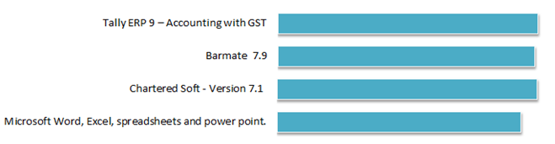
SKILLS

