CIVIL ENGINEER
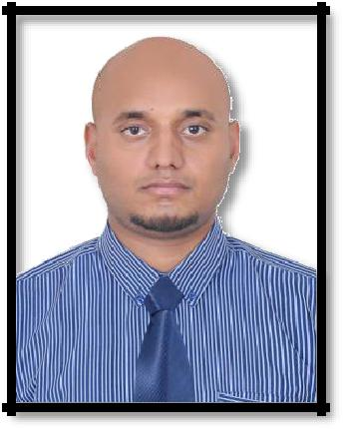

GHULAM

ghulam-391453@2freemail.com

CURRENT VISA STATUS | EMPLOYMENT VISA
D.O.B | 06/05/1989
NATIONALITY | PAKISTAN
ACADIMIC QUALIFICATION:
 | BACHELOR IN CIVIL ENGINEERING |  | 2013
 | FSC (PRE- ENGINEERING) |  | 2007
 | SECONDARY SCHOOL CERTIFICATE (SCIENCE) |  | 2005
PROFESSIONAL MEMBERSHIP:
 | • MEMBER OF PAKISTAN ENGINEER COUNSIL |  | 2013
 | • AFFILIATED MEMBER SOCIETY OF ENGINEERS UAE |  | 2016
 | • G+1 APPROVED ENGINEER MUNCIPLITY SHARJAH |  | 2016
CAREER HISTORY:
COMPANY | AL FAROOK BUILDING CONT. LLC | (MARCH 2018 Onward)
PROJECTS 1: | * VILLA (G+1) + GARAGE+COMP WALL+KITCHEN BLOCK (SIYOH 13)
 | DIYAR ENGINEERING CONSULTANT
PROJECT 2: | * VILLA (G+1) + GARAGE + COMPOUND Wall (SIYOH 11)
 | SMART VISION ENGINEERING CONSULTANT
PROJECT 3: | * WARE HOUSES (G+MEZZ) + COMPOUND WALL (SAJJA)
 | SMART VISION ENGINEERING CONSULTANT

JOB NO 2
COMPANY | KHUTWA AL SAREEAHA BUILDING CONT LLC (AUG 2016 TO APRIL 2018)
PROJECT | * VILLA (G+1) + GARAGE+COMP WALL (RAHMANIYA 6)
 |  | EMIRATES ENGINEERING CONSULTANT
DUTIES
 | • Supervision for cutting, bending and fixing of rebar according to bar
 |  | bending schedule. Supervision of formwork fixing, Concrete Pouring
 |  | and curing
 | • Coordination with Client and subcontractor for smooth flow of
 |  | work. Checking quality of work and labor management
 | • To make payments Bills and site related reports. To oversee site
 |  | safety procedures
 | • Implementation and supervision of technical Design, Drawings and
 |  | specification as per project
 | • Pre planning of construction activities to deliver the project on time.
 |  | Layout and leveling work on site as required.
 | •
 |  | Determined project feasibility by estimating the quantities and cost
 |  | of labor, equipment, and materials.
 | • Monitored sub-contractors in the completion of daily operations to
 |  | ensure project progress and optimal performance
 | • Installation of firefighting & fire alarming as per drawing
JOB NO 3

CONTRACTOR:

* FAUTAEH INTERIOR & DECORE

AL NARJIS KINDERGRTEN SCHOOL UMM AL QAWAIN

CONSULTANT:

DUTIES

MINISTORY OF EDUCATION AJMAN

• Reconstruction & interior of building

• Pvc vinyl flooring, roof ceiling gypsum work, floor tiles, installation

electrical & internet system

• Installation of fire fighting & fire alarming system.

JOB NO 4

PROJECT

* MSL PVT LTD

(JAN 2012 & 2013)

(ASSISTANT STRUCTURAL ENGINEER)

CONSTRUCTION OF 4 LANE MOTOR WAY, FAISALABAD TO KHANEWAL (M-4)

CONSULTANT:

DUTIES

NATIONAL HIGH WAY AUTHORITY PAKISTAN

• Provided site engineering services including installation of Post

Tension structures
• Construction of underpass & culverts
• Conducted structural inspections for various structures including
concrete and steel structures, roadways, and underpasses
• Implemented safety measures during construction
• Executed scheme to manage inventory in order to regulate demand
and supply of materials

TECHNICAL SKILLS * AUTO CAD, MS OFFICE,

PERSONAL ABILITIES AND SKILLS:

- MANAGEMENT SKILLS, WORK AS A TEAM OR GROUP LEADER STRONGLY COMMITTED TO ASSIGNED TASK

- ABILITY TO MAKE INDEPENDENT JUDGMENT AND RESOLVE ISSUES WITH TIME CONSTRAINTS

- STRONG INTERPERSONAL AND COMMUNICATION SKILLS (WRITTEN & VERBAL)

