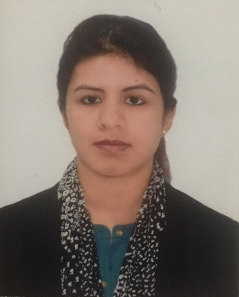
Roohi

Email: roohi.391464@2freemail.com

Professional Summary:
To be exceptionally well organized with a track record that demonstrates self-motivation, creativity and vision to achieve both personal and institutional goals and to be a part of team work and dedication towards responsibilities.
- Adaptable to work under pressure with full enthusiasm and good at team work.
- Ability to pick up and learn very fast within the given period.
- Ability to archive all targets set or given by the management.

Education:
Masters of Business Administration in Human Resource – Annamalai University,Dubai, UAE
Skills:
Human resource assistance
Administration
Customer service

Career Summary:

OPERATIONS SUPERVISOR (2010-2018)
INTL FCStone Commodities DMCC
- Managing the HR/administrative tasks such as work visa processing and cancellation for all employees.
- Maintaining the accounting records of the company.
- Supervision of Operations department.

SENIOR SALES MANAGER (2005-2010)
RIVOLI GROUP LLC
- In-Charge of customer care and service.
- Attending customer complaints.
- In-charge of the shop environment and keeping maintained records.
- Keeping daily sales records and outgoing stock records.
- Analyzing the competitive products.
- In-charge of merchandizing the products in the showroom.

HUMAN RESOURCE EXECUTIVE (2004-2005)
SWATCH GROUP
- Managing administrative jobs and working end to end with the group’s hiring team.
- Managing correspondence independently
- Handling the employee records and data.

