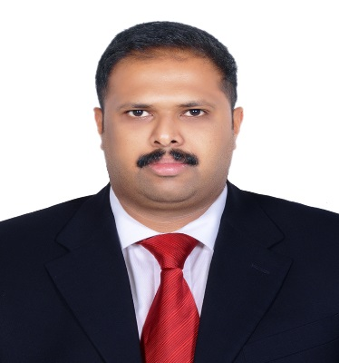
Byju
Email: byju.391482@2freemail.com

Sr. CREDIT CONTROLLER - Professional Summary
Experienced Commercial Credit Controller who has worked closely with loan administrators to reduce lending risk. Adept at financial research, utilizing productivity software and making presentations on commercial credit to executive teams. Sound knowledge of credit systems, financial collections, debt management, reporting and all related credit-based system operations.
Core Competencies and Strengths
- Perfect writing skills combined with superior communication ability.
- Effective decision-making | Commercially adept | Team worker
- Superior customer service and interpersonal skills.
- Effective under little or no supervision
Professional Experience
Sr. CREDIT CONTROLLER – (OCT 2009 TILL DATE)
Accurately and efficiently evaluated credit applications for asset-based lending and financial services division. Performed accounts receivable tasks such as posting and reconciling cash receipts, handling client billing, and printing and distributing weekly reports. Reviewed clients and account debtors for creditworthiness. Investigated clients for financial crimes.
Area of operations: Bank Finance, Insurance companies, Spare parts retails and Export& Shift leasing rent a Car
- Ensuring detailed review of the company’s credit control procedure and implementing enhancement.
- Setting & monitoring credit limits, collection & targets and running age debt reports.
- Followed up & managed the outstanding sales balances falling due and contacted customers before the balances become overdue to confirm payments
- Provided customer service support and professional financial guidance.
- Prepared written credit-approvals and denials.
- Managed the negotiations of the agreements.
- Demonstrated excellence in managing the debt collectors for the collection of the payments on time.
- Expertise in gathering the market intelligence, tracking competitors’ activities and providing valuable inputs for fine tuning the strategies as Credit Analyst; possess sound knowledge of Oracle R12
- Achieved collection targets consistently & maintained healthy DSO of customers through timely collection of payments
- Maximized customer satisfaction matrices, monitored customer complaints on loans & maintained healthy business relations

Achievements:
  - DSO achievements in 2011 ,2012, 2014
  - Employee of the Month 2014 with record day DSO achievement.
  - Successfully developed new IT report in Credit Control department.
Projects: Customer Merge on Duplicate Customers

ACCOUNTS EXECUTIVE: EMPIRE ROCKS ENGINEERING LLC (DEC07- SEPT 2009)
Research within targeted accounts to identify key contacts and critical account information. In addition, having the direct contact and valued information through the key contacts and decision makers.
- Effectively assessed credit risk and (current and potential) client viability, analyzing financial statements and cash flow of customers.
- Performed (quantitative and qualitative) analysis of requests for loans and lines of credit.
- Provided customer service support and professional financial guidance.
- Prepared written credit-approvals and denials.
CREDENTIALS
- MFC- Master of Finance and Control, Maduri Kamaraj University (2006)
- B.Com (Finance & Commerce), Mahatma Gandhi University (2004)

Trainings/ Seminars
- Seminar- Credit Analysis & Review
- Personality Development, Time Management, Negotiation Skills

Project

- Client: Oracle R12, Dubai (Oct 2012 - Mar 2013)

Team Size: 7

Responsibilities: To maintain the Sales Ledger, ensuring that it is accurate & kept up to date and to monitor outstanding debt owed to the company.

Computer Knowledge

- Microsoft Office, Tally & ERP, Oracle and Software Application, Carpro

Personal Information

- Date of Birth: 22 Jan 1982
- Address: Al Quasis Dubai
- Languages Known: English, Hindi, Tamil & Malayalam

