HARISH
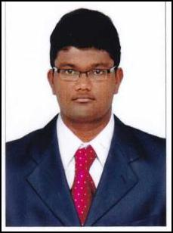

MECHANICAL ENGINEER

Email: harish.391598@2freemail.com

OBJECTIVE:

Seeking for a suitable position to pursue a highly rewarding career and healthy work environment where I can utilize my skills and knowledge efficiently for the personal as well as organizational growth.

KEY COMPENTENCIES:

- Pump selection & Data sheet.

- Equipment Specification.

- Heat & Cooling load calculations.

- U-Value Calculations.

- ESP Calculations.

- Duct Routings.

SOFTWARE PROFICIENCY:

- REVIT Families.

- Auto CAD.

- MS Office (Word, Excel, Power point).

ACHIEVEMENTS:

- Paper presentation (Effect of casting defect analysis usingAl-ADC12 material during casting process).

- Successful completion of MEP design for new commercial building. (Car Wash).

WORK EXPERIENCE:

Company: Conserve Design Solutions.

Position: Assistant Mechanical Engineer.

Duration: Sep 2017 to till date.

KEY RESPONSIBILITIES:

- Selection of pump hp rating based on process inputs.

- Preparation of equipment specification & pump data sheet (General purpose centrifugal pump, Fire water pump).

- Preparation of heating & cooling load calculations for HVAC design.

- Preparation of ESP calculation.

- Preparation of U-Value calculation.

- Preparation of duct sizing, routing & accessories.

QUALIFICATIONS

Degree: B. Tech in Mechanical Engineering, 2017, Kalasalingam University (CGPA-7.60)

HSC: SRV Matriculation Higher Secondary School, Tiruchirappalli (83.33%).

PERSONAL INFORMATON

Gender / Nationality

: Male / Indian

Date of Birth

: 20/02/1996

Languages Known

: Tamil & English

Marital Status

: Single

