Languages Known:

• English
1

• Tamil
2

• Telugu
3

Career Objective

To achieve excellence in working as dynamic professional offering solutions to business using the best available where my analytical ability and analyzing quest are used maximum for growth of the organization and to grow with the organization. Seeking a challenging position in well-established company that offers professional growth and ample opportunity to learn and enrich my competencies in my profession

Professional skills

 |  | Analysts
Documen- | Analysis | must be
 |  | Good
tation & | Skills
 |  | Communi-
Specification
 |  | cators
Skills
 | Problem
 | Solving
 | &Critical
 | Thinking
 | Skills

Maheswaran.
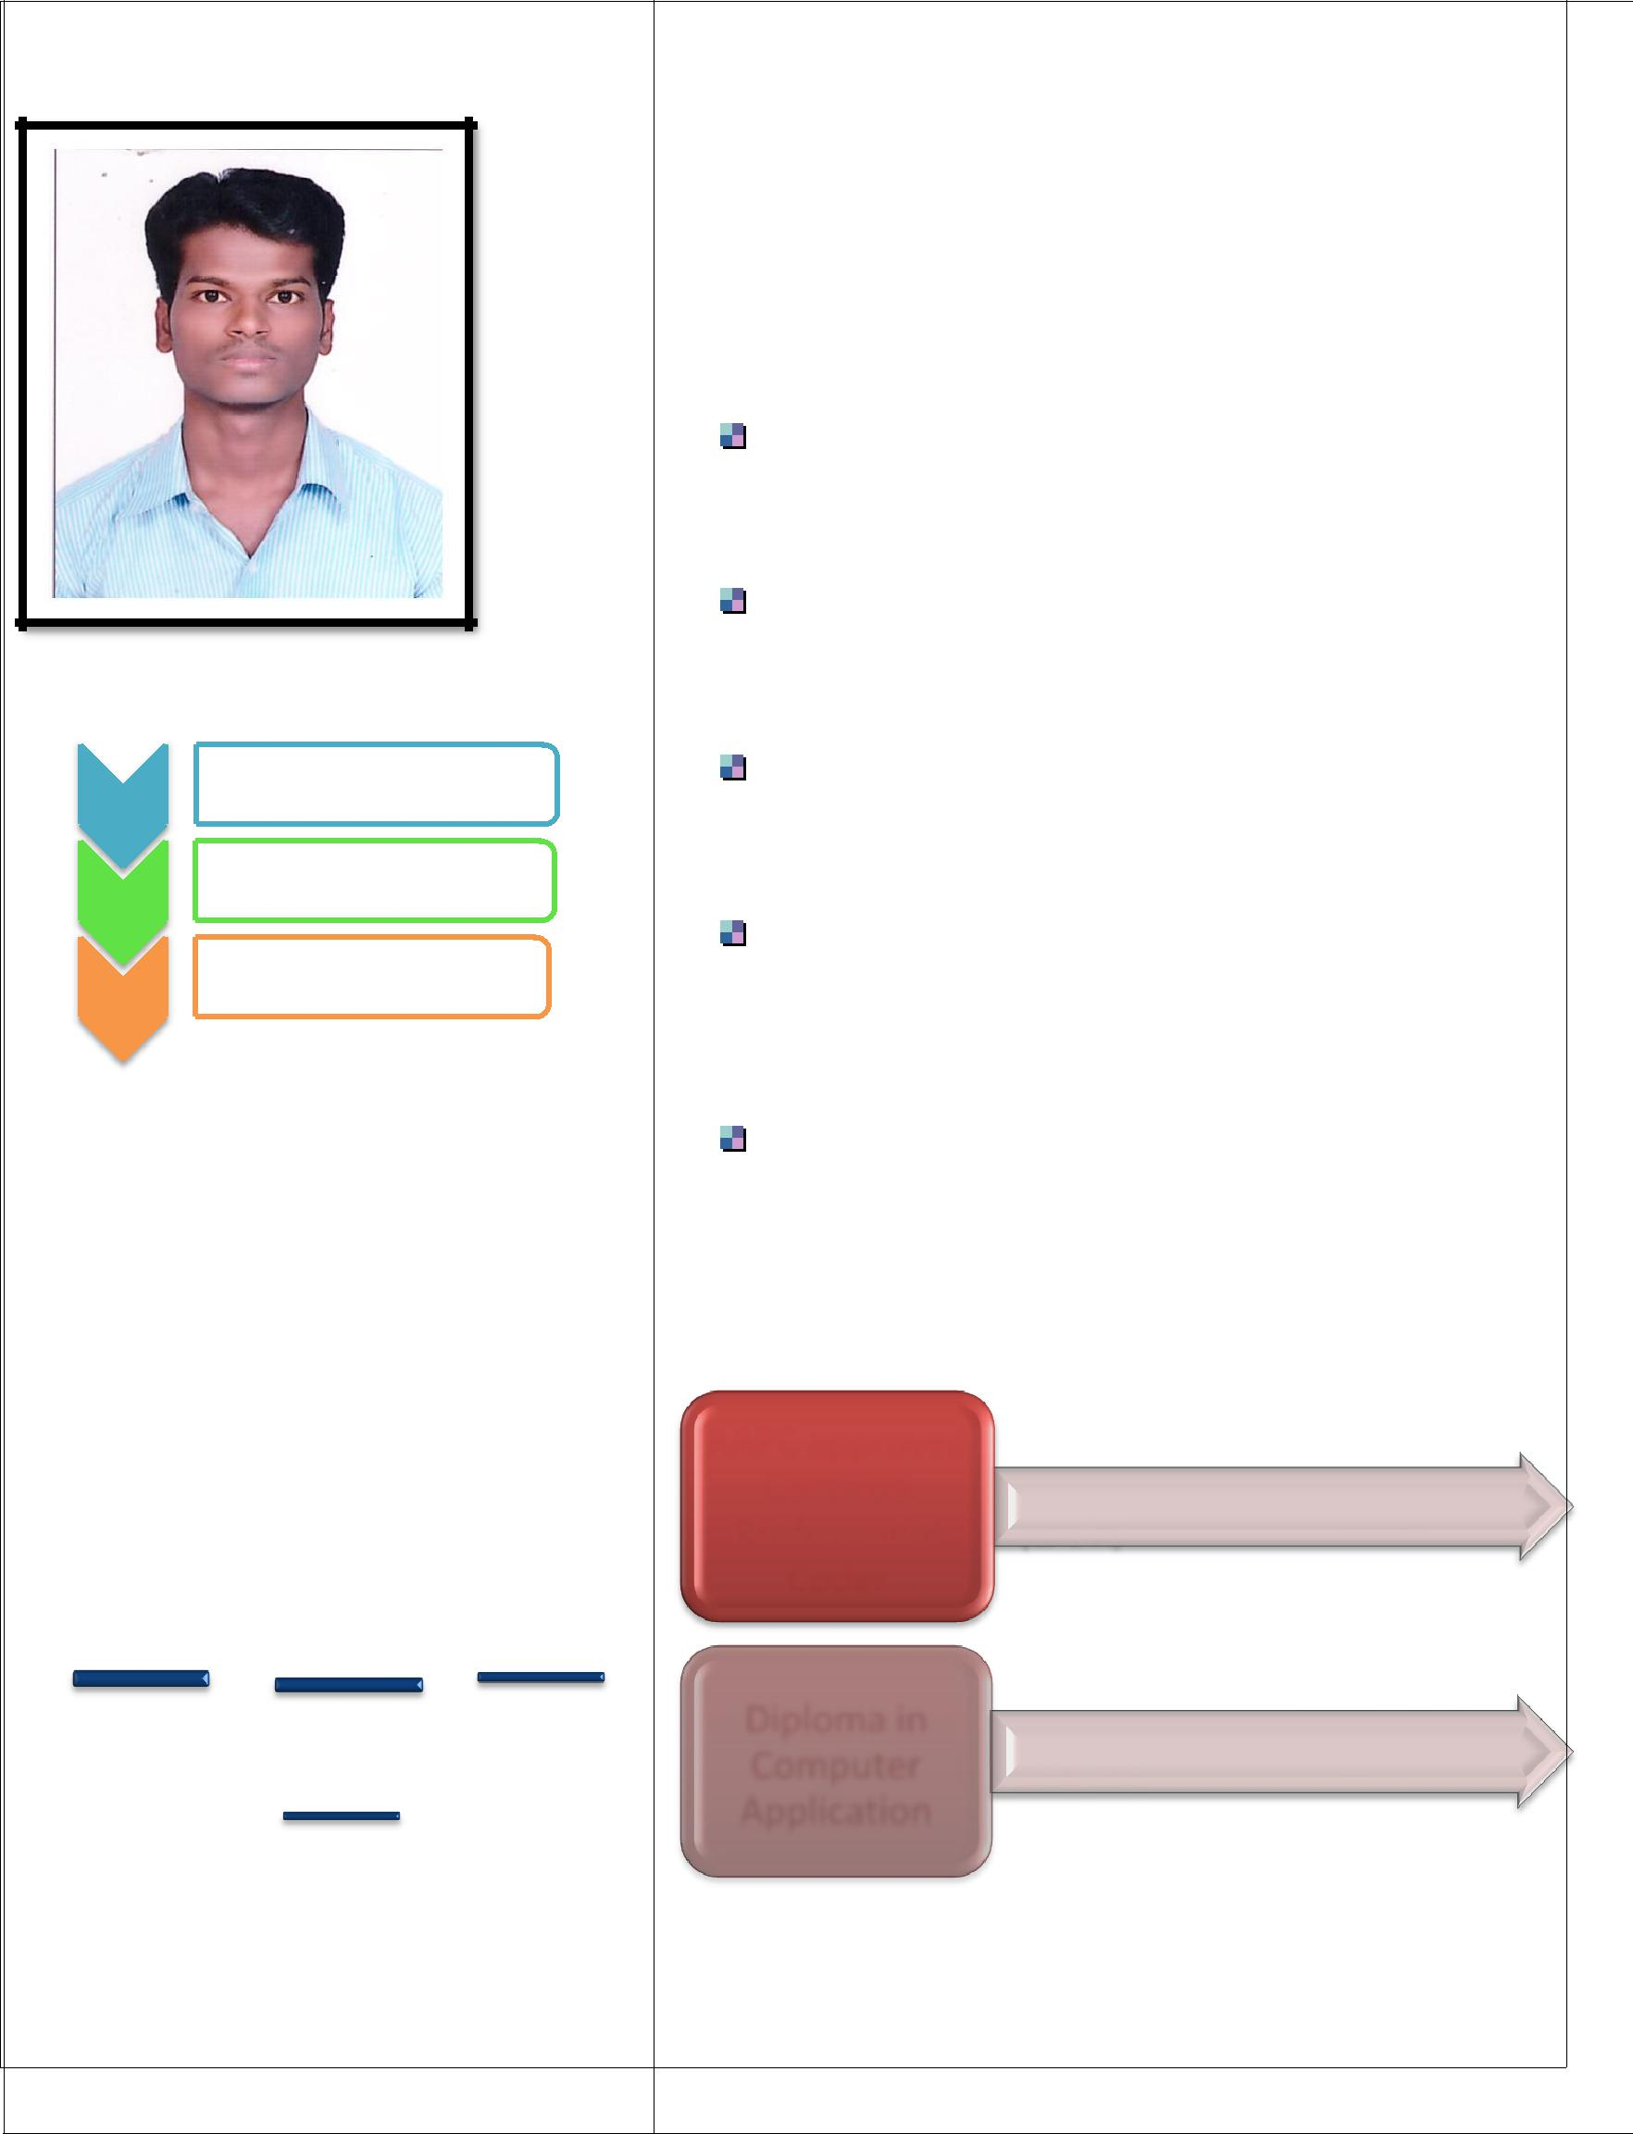

: maheswaran-391655@2freemail.com

Work Experience:
Scio Health Analytics |  |  | : Chennai
o | Designation |  | : Clinical Reviewer
o | Duration |  | : July 2017 - march 2019
Episource India private ltd : Chennai
o | Designation |  | : HCC Coder - (CPC-A)
o | Duration |  | : September 2016 -June 2017
Rajans Hospital |  |  | : Ramanathapuram
o | Designation |  | : Staff Nurse
o | Duration |  | : Feb 2016 to July 2016
SIMS Hospital –SRM Institute for Medical
Science : Chennai
o | Designation |  | : Staff Nurse
o | Duration |  | : March 2013 to Dec 2015
Mediscope Hospital |  |  | : Bangalore
o | Designation |  | : Staff Nurse
o | Duration |  | : June 2009 to December 2012

Certification:

AAPC approved
Certified
Professional • (CPC-A)

Coder

Diploma in
Computer _{• DCA- CSC}
Application

Educational Qualification:
• 70% | • 74%
General
Nursing & | Certified
Midwifery | Profession
(Indian | al Coder -
Nursing | (AAPC)
Council)
SSLC , HSC, | DCA and
 | Tally
• 80% | • 75%
Job Profile & Responsibilities Entrusted:
Clinical Reviewer
2 years | Chennai
Hcc Coding
10 Months | Chennai
Nursing
6 years | Bangalore, Chennai

Clinical Reviewer Job Profile:

Familiarity with the insurance Claim Procedure

Experience in Health care as a clinical Reviewer (Medical Insurance Coordinator)reviewing Medical records validating the Reimbursement with the patient Received Services along with Accuracy
Used understanding of medical terminology& pharmacology to ensure proper coding at first time
Remained infrequent Contact with medical insurance companies to expedite smooth processing
Submitted and processed insurance claims, conducted medical code verification assessment Processed and documented insurance payments created weekly statements recording balances and expenditures
Organized the internal fillng system, inputted data into internal database, processed and retriewed patient information from system.

Coding Experience- Hcc Coding

Perform Professional Coding for Health Care Department

Driven Medical coding Specialist Skilled at the organization, Codification & Processing of Medical coding documentation. Adept at coordinating with providers to follow documentation policies reviewing and interpreting medical documents and assessing operating procedures
Specialize in the development of operational procedures and coding

- Summary –Hcc Coding

Efficient and accurate medical coder with full awareness of ICD 10, CPT.

Vast knowledge of medical terminology, procedures data entry excellence and proficiency in a wide range of commonly used medical and standard administrative applications and software. Exercised proficiency in coding Disciplines of inpatient, outpatient, Facility and physician care Code medical Records with ICD 10 Guidelines Processing 200 Claims /day , maintaining the quality 98-100% and achieving productivity Goals.
Transforming verbal descriptions of diseases, injuries, medical, surgical, diagnostic Procedures into alfhanumerical Designation –(ICD 10 Guidelines)

Highlights – coding:

Medical record Processing

Codification

Statement Analysis

Accurate Data entry Skills

Record Assessment

Nursing Experience - (Responsibility Entrusted):

Rendering comprehensive Nursing care to critically ill patients with various conditions cardiac, Non- cardiac general medicine and surgery
Maintain good nurse patient relationship

Administering Emergency Drugs

Current Comprehensive knowledge and Skills in manage all the types of medical emergencies

Job Profile –(Nursing)

Assessing physical Psychological and psychosocial needs of the client in the ICU environment.
Monitoring Vital signs of client

Maintaining patient Airway-performing Tracheal, oral and nasal Suctioning as required, Adequate chest physiotheraphy to mobilize the secretion administering oxygen Monitoring Fluid- Electrolyte balance-intravenous canalization administering intravenous Fluid, monitoring and maintaining adequate Record of intake and output Administering Drugs- Oral , Sublingual, intravenous, intradermal, subcutaneous intramuscular.
Assessing Skin integrity of bed ridden patients Maintaining Therapeutic Relationship with patients.
Research current Standard of care to contrast with available medical, nursing necessity &Clients guidelines across broad spectrum of Specialities to ensure the most positive outcome for patients as well as providers.

Personal Skills

Hard Working, Sincere and Documentation. Good decision making and analytical skills. Computer literate (MS, Word, Excel, Access Tally) Completing received Audits with Quality Achieving Quality and production target Comprehensive problem solving abilities Excellent verbal and written communication skills Ability to deal with people diplomatically following project related protocols and instructions Escalating issues, identify trends...

Updating all the logs like productivity, Clarification log, and other logs applicable on a daily basis

Personal Profile:

Name

Father’s Name

Date of Birth

Gender

Nationality

: A.Maheswaran

: A.Anguchamy

:23/07/1988

: Male

: Indian

