ARUN

PERSONAL DETAILS
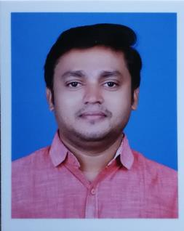

Arun-391658@2freemail.com

SUMMARY

Respected and dedicated professional with 12 years’ experience providing internal employee development, team effectiveness and leadership development consulting to all levels of an organization.

OBJECTIVE

To further develop my

knowledge base and grow with the Organization I am involved in.

EDUCATION

Graduation - 2004

University of Calicut

Victoria College, Palakkad

Date of Birth : 25/02/1983

Gender : Male

Marital Status : Married

Languages Known : English, Malayalam, Tamil

License : Holder of Indian license.

TOTAL EXPERIENCE: 12 YEARS

PRODUCT EXECUTIVE April 2005- April 2006 Vehicle loans

CREDIT MANAGER

2006 – 2018

Handled various roles and recently undertook an assignment of managing 5 branches and coordinating in their Collection and recovery activities

ACHIEVEMENTS

Award for Best Product Executive All India-2008

Award for Best Field Officer All India-2009

 |  | SKILLS
Personal |  | Computer
➢ Leadership |  | ➢ MS Office
➢ Communication |  | ➢ UNO
➢ Critical Thinking
➢ Decision Making |  | Languages
➢ Problem Solving
➢ Flexibility |  | ➢ Malayalam
➢ Time Management |  | ➢ English
➢ Work under Pressure |  | ➢ Hindi
➢ Adaptability |  | ➢ Tamil
➢ Conflict Resolution
 | JOB DESCRIPTION
• | Branch Management | • | Accounts
• | Field Investigation | • | Team Manager
• | CSR Implementation | • | HR And Administration
• | Dealership Visit | • | Insurance Work
• | Customer Relations | • | Property Loan Valuation
• | Credit Verification | • | Vehicle Valuation
• | Collection Recovery Management | • Developing And Implementing Sales Plans

- Regular Sales & Operations Meetings

REFERENCE

References are available on demand

DECLARATION

I do hereby declare that all above mentioned information is true and correct to the best of my knowledge.

Place: Palakkad

Arun

2

