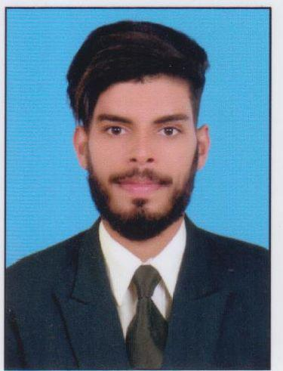
Naseer

Email-ID: ​naseer.391678@2freemail.com
Experience: 1 year

Career Objective:

To obtain a position that will enable me to use my strong organizational0 Skills, project Management Skills, Educational background and ability to Work well with people.

Educational Qualification:

Bachelor of Engineering (BE):

Specialised:​Civil Engineering.
University: Visvesvaraya Technological University Belgavi–India.

Grade Result: First Class

Technical Skills​:
- AutoCAD​.
- MS​office.

- Basic​STAADpro.

Presently working:

Designation: Site In charge.

ProjectsDetails:

- ​Project: Kasaragod Medical College
Academics block, Examination Hall, Sump & Pump house.
- ​Place: Kasaragod , (Kerala).

Job Role:

As a Site Engineer:
- ​Survey Coordination of site and issuing Site Material Request (SMR) to Project Manager/Project Coordinator with respect to the design Specifications.

- ​Maintaining Daily Progress Report and keeping record of material Consumption and requirement.

- ​coordinating with all contractors of respective work RCC, BBM, Plaster, Plumber, tiling, Electrical etc.

- ​Verifying and analyzing of technical drawing sand materials as per Standard.

- ​Maintained proper documentation of all the daily work being carried Out.

- ​Communicating with seniors for any issues and finding a suitable Solution.

- ​Reviewed the development and made sure that the entire work process As per scheduled time.

Areas of Strength:

- I​am a honest, Self-motivated, Hardworking boy with positive Attitude towards my career and my life.

- ​Quick learner and Adaptable.

- ​I am comfortable working as a part of team.

Personal Details:
Name: NASEER​

Date of Birth: 30-01-1993

Sex : Male

Nationality: Indian

Languages known: English, Hindi, Malayalam, Kannada and Thulu

Declaration:

- Hereby declare that the above particulars furnished by me are True to the best of my knowledge and belief .I assure you if I got a Chance, I will execute my work to the full satisfaction of my superiors.

(NASEER)

